

**ME 492/ECE491 – Senior Design**

**Group 2 - winter 2014**

**Final Design Report**

**Industrial Parts Counter**

**Professor: Dr. Latcha, Dr. Gu**

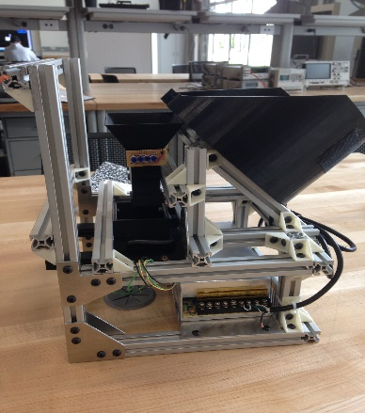

**Team Members**:

Paul Kruchko (EE)

Michael Laba (ME)

Bryan Jagielo (EE/CE)

Xiaoang Tong (EE)

Monika Shaeff (CE)

Ran Ao (ME)

Xinfeng Shi (ME)

**Abstract:**

In factory settings it is common for small parts that are being used in the assembly process to be lost to the factory floor and discarded. Given the volume of production tens of thousands of small parts could be lost in single day. To mitigate this problem, Group 2 was tasked with designing and implementing a solution that would allow these small parts to be dispensed into the awaiting hand of an assembly line technician without any loss to the factory floor.

The system designed was a closed loop, feed-back controlled rotating disk parts feeder that was able to dispense a given quantity of desired parts upon user request. When implemented the system was able to accurately and timely dispense the desired number of parts in the hand of an operator. The Mechanical sub-system design enlisted the use of aluminum 80/20 extruder for the machine frame, while the rest of the solid mechanical components were 3D printed ABS plastic, allowing for a robust yet light design.

The system was controlled with an Arduino based microcontroller board that regulated the speed and torque output of a DC servo motor, using the current draw of the motor as the sensory feed-back for closed-loop control. The system was able to count the varies parts being dispensed to the user through use of two IR LED and phototransistor sensor arrays, each strategically placed to create redundancy in counting. The user/operator was able to interface with the machine through an intuitive menu driven LCD screen and ergonomically sized pushed buttons. The overall design was found to be functional, aesthetically pleasing, and user friendly. The design was of such quality as to win the senior design competition, competing aginast other machines of the same requirements and objective, for the fall 2014 semester at Oakland University.

**Table of Contents:**

1. **Introduction**…......................................................................................................................1
2. **Design Specifications**...........................................................................................................1
3. **Design Overview**…..............................................................................................................4
4. **Mechanical Subsystem**…....................................................................................................8
5. **Electrical/Electronic Subsystem**…….................................................................................36
6. **Computer/Software Subsystem** ……................................................................................55
7. **Discussion**……....................................................................................................................61
   1. **Technical Discussion**…………………………………………………………………61
   2. **Professional and Societal Context**………………………………………….…….….62
      1. **Engineering Standards**……………………………………………….……..…..62
      2. **Safety**………………………………………………………………….….………63
      3. **Economic factors**……………………………………………………………...…63
      4. **Reliability**……………………………………………………………………...…64
      5. **Aesthetics**…………………………………………………………………………64
      6. **Potential customers**………………………………………………...……………64
      7. **Societal impact**…………………………………………………………...………64
   3. **Information Literacy**………………………………………………………...………64
8. **Conclusions and Recommendations**…………………………………………………….65
9. **Appendices**…………………………………………………………………………..……66
10. **References**……………………………………………………………………….………..107

**Introduction:**

1. Description of the project challenge

The challenge of the project was to produce a machine that could be used on an assembly line. The machine would be useful by helping workers counting out small fasteners or parts to be assembled as the main assembly passes by on the line. The machine would be able to provide the correct number of parts each time the line worker requested it. This would eliminate workers counting by hand and either coming up short on their count or taking too many parts. Extra parts tended to be discarded on the floor which is both a waste of materials and a safety hazard.

1. Brief description of the design solution to the project challenge

The solution that we came up with was a rotating disk-feeder design that uses a bowl to hold the main part population. Inside the bowl a disk with cut-outs took each part one at a time to the top of the bowl and dispensed it down a funnel. The funnel was lined with sensors that counted the parts as they fell into the presentation bin. The presentation bin held the parts until the count goal was achieved. From here the operator pushed on the slider just under the bin. This allowed the parts to drop into the operator’s hand.

**Design Specifications:**

The system that Group 2 designed was a closed-loop, feed-back, electronically controlled rotating part feeder that agitated, actuated, and organized a set of homogenous hardware components that were counted and dispensed into the awaiting hands of the operator/user.There were basically four subsystems in the mechanical design: screening subsystem, transportation and detection subsystem, dispensing subsystem, and supporting frame subsystem.

The hopper bowl, the disk, and the agitators made up the whole screening subsystem. They are all printed by 3D printer to ensure high accuracy of the size. Six different disks, each with a different type of cutout were designed in order to meet the project requirements that the system was to accommodatedifferent sizes for the parts to be dispensed. And also the bowl inserts are used to fit different parts. The hopper bowl was designed according to the total volume of the largest parts to make sure it’s big enough to hold any six kinds of fasteners as necessitated by the project requirements that the system should be able to dispense a variety of six different types of fasteners. The diameter of the bowl was decided by the diameter of the plate (200mm), which itself was decided by the length of the longest fastener; the 4x50mm machine screw. All of the materials were be put into the gradient hopper bowl, and the plate at the bottom of the bowl rrotated, being driven by the motor, and the agitators stirred up the parts. The parts inside the bowl fell into the cutouts of the disks under the influence of gravity and the agitation. When the single part was rotated onto the higher side of the plate, all the parts dropped through the gap one by one, causing singulation[1] of the parts for counting.

For the transportation subsystem, there was a funnel with sensors inside. The parts dropped into the funnel one by one, and the eight pairs of IR sensor on two levels counted the parts as they went through. When the count reached the requested quantity, the feedback control applied an electric brake to stop the motor. The upper size of the funnel was bigger than the lower size to avoid getting stuck. According to the parts quantity the user needed, there was a motor speed control implemented to speed up the rotation or slow it down. This control will make sure we can transport enough parts in a certain time. After careful examination of the system’s static and dynamic characteristics it was determined that a motor with a minimum torque output of 20oz.-in. would be sufficient. Given that the there is considerable torque loss in the shaft of any given motor (~10%) and the need to both observe and control the speed of the motor it was determined that the Pittman/Ametek8224 12V DC servo motor with a G35 wide-faced gearbox with a 60.5:1 ratio. This was perceived as the material solution for our motor needs given that the gear motor offered a continuous torque of 157.3 oz-in at 130 rpm, giving our needs this selection offered a safety factor of 8.Motor control was implemented with a PID controller in software on the microcontroller to control velocity output for desired velocity set-point of each fastener and to help control the required torque. The feedback for the motor was provided for by the current sense pin of the PololuMD01B-VNH2SP30 Motor Driver Carrier, which also allowed us to control the motor via PWM..

For the dispensing subsystem, there was a push slider and a presentation bin. Afterthe right numbers of parts were dispensed, the motor would stopped rotating and the certain parts will be inside of the dispenser. Two springs with proper spring constant are on the dispenser, which can make it go back to the original position after the user push and get the parts.

For the supporting frame subsystem, the frames are utilized to hold up all the mechanical and electronic components. The cross section of the frame was20mm×20mm, and the material was aluminum alloy to ensure that it was strong and light enough to make the whole setup steady. The frames were fixed together by the joints, which are printed by 3D printer.

**Design overview:**

In order to discribe the overview of the mechancical system. We first looked at existing machines in industry and broke down what made them successful. One of the resources that were consulted for design inspiration and theoretical understanding was the website for Carnegie-Mellon Universitie’s Micromanufacturing research institute[1].

After examining a few machines we came to up with the following flow chart which each part followed in order to be acuratly organized, counted and moved from a major parts group. We would incorporate the same ideas into our design in order to make it successful

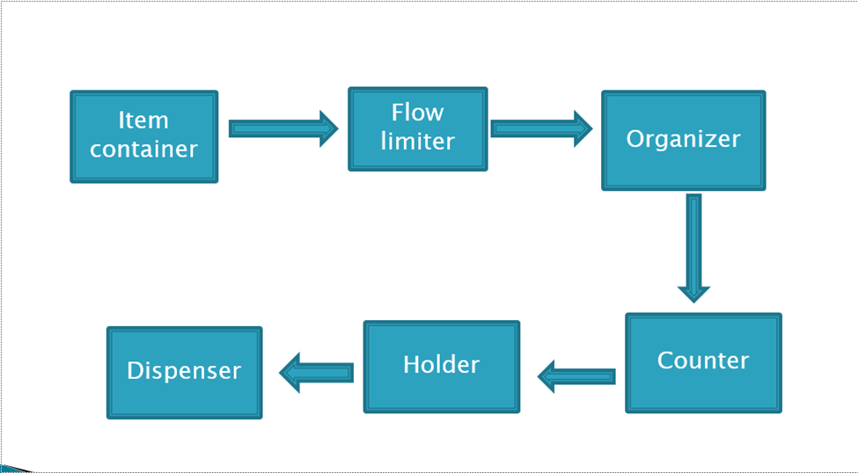

Figure 1. Functional System Flow

As seen in figure 1, the main population had to be first contained. Then the machine had to have some way of initiating the parts to move. Most machines used motors or agitators to create a mass flow from the major population of parts in the machine. The parts then are organized by geometry and orientation from the main material flow. Any part that did not match the orientation or the requested geometric restraints was rejected back to the major population. This allowed for a controlled flow of parts to feed one at a time into the counter. As parts move past the counter, the machine kept track of how many fasteners were going to be dispensed, what the count is and how many parts are left in the bowl. The parts then moved to a holder. In the holder, orientation may or may not matter depending on if orientation needs to be held for later processes. In our case we did not need to hold any particular orientation as long as all the parts where contained in the holder. The holders’ main job was to hold the current count of parts to be dispensed. This was done to ensure that the operator is to get all the parts at once out of the dispenser, instead of parts coming out one at a time. The final piece was the dispenser itself. Each machine needed a way of presenting or releasing the held parts to the operator.

We needed to control aspects of the mechanical side, so we made a second chart that would work with the mechanical flow to ensure control to the machine.

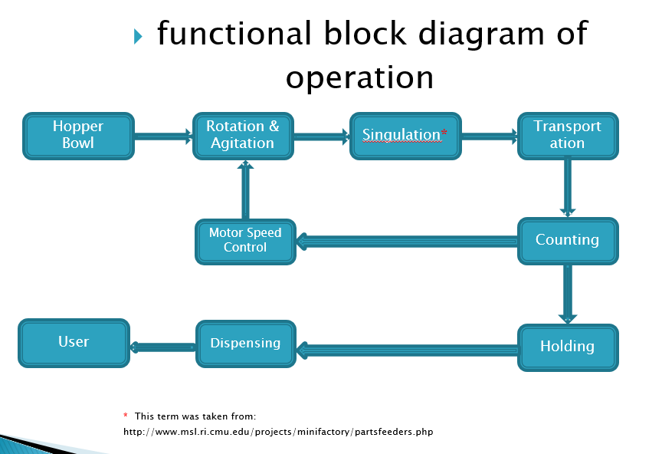

Figure 2.

Each section in the diagram above was a strategy used in controlling the number of parts and part flow within the machine. The microcontroller would have feedback from sensors in the funnel and dispensing bin to control the motor speed and ultimately the part flow within the machine. This would mean that we could control the on time delivery of each count, know how many parts have been dispensed, how many parts are in the machine, and most importantly, how many parts are in the count. The microcontroller would have the ability to do the following: allow for user to select part type, count, control motor speed, keep track of parts in the machine, alert the operator when the parts are ready to dispense and start the count again after the operator retrieves the parts.

**Mechanical Subsystem:**

The mechanical subsystem is all pieces or parts of the machine that provide support or function to the machine. Each part of the machine had to be selected or made with both function and the ability to be assembled in mind.

Design Calculations

Considering that we should have some gaps between that “Gaps” for our parts, we need make the diameter bigger. Also, we have 50 parts, and we need enough volume for these 50 parts.

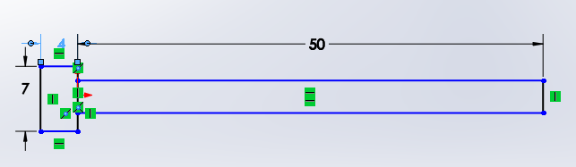

(50mm screw)

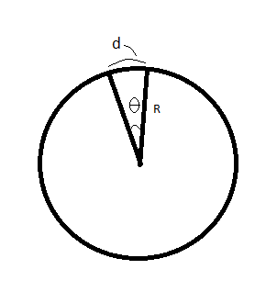If we set 6 gaps in a plane, and we see each gap occupy θ angle. Then d= θ, R≈54mm   
(θ<60°)

1) Set θ=5°=0.0873rad, we find R=618.8mm

2) Set θ=15°=0.262rad, we find R=206.3mm

3) Set θ=30°=0.52rad, we find R=103.13mm

4) Set θ=40°=0.698rad, we find R=77.3mm

5) Set θ=50°=0.87rad, we find R=61.9mm

Thus, we can set the diameter of the circle as about 206.3mm, which is the third option. We chose 200mm for the diameter of the planes. Then every part can work for this circle. All we need is changing the plane for different part.

**Some Calculation about the Torque**

1, for the 10*25mm Socket Head Cap Screw (Heaviest one)

$M_{total}=1.36kgG=13.328 N$ The angle was set as 45 degree

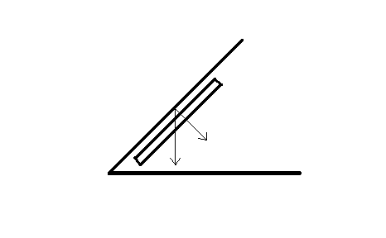So the support force of the plate: $N=G*Sin45=9.424 N$ (1)

The friction between the parts and the plate: $f=µ*N=1.4136N$ (2)

(All the calculation above ignored the gaps area, and also ignore the friction between the parts and the bowl bottom, because their friction should be cancelled out.)

The Torque that needed: $T=F*r$ (3)

It’s hard to decide the radius r, we just set the r biggest, which is r = m

So the torque we need: $T=F*r=1.4136*0.1m=0.14136N*m$

Then the power should be: $P=T*n*η/9549$ ($η=0.8$) (4)

As long as the n is decided (which is r/min) the power P can be calculated.

**The range of the moment of inertia of Plates:**

For the 54mm Screw: $I=0.2803g*m^2$

For the 35mm Screw: $I=0.3163g*m^2$

For the 4mm Nuts: $I=0.2459g*m^2$

For the 10mm Nuts: $I=0.3542g*m^2$

For the Anchor: $I=0.3393g*m^2$

For the anchor srew: $I=0.3633g*m^2$

So basically the range of the moment of inertia of plates are:

I: $0.2459g*m^2$ ~ 0.3633g*m^2

**The range of the moment of inertia of Plates:**

Assume all the 50 parts as a point, and at the edge of the plates:

For the 54mm Screw: $I=3g*m^2$

For the 35mm Screw: $I=13.6g*m^2$

For the 4mm Nuts: $I=0.326g*m^2$

For the 10mm Nuts: $I=4.665g*m^2$

For the Anchor: $I=0.93g*m^2$

For the anchor screw: $I=11g*m^2$

So the range of the moment of inertia of both plates and parts are:

I: $0.57g*m^2$ ~ 13.92g*m^2

But the actually “I” should be smaller than what from the calculation.

**For the spring constant of the springs that use on the presentation bin:**

For the heaviest parts which are 10×25mm Socket Head Cap Screw, each one:

$$m_{ea}=27.2g$$

And consider that the user need six parts of that, so

$m_{6}=163.2g$ And $m_{silder}=249.66g$

So, $m_{total}=412.86g$

Set the friction coefficient $µ=0.15$, which is the “most forces needed” situation.

And the friction f between the sliders:

$f_{max}=N×µ=G×µ=0.6075N$ (5)

Some preload (less than 5mm) should be applied. The inner distance is 65mm, and the outer surface is 70mm. The original length should be a little smaller than 65mm, could be 60mm, and then we have about 5mm preload. So the total extension should be 80mm:

$F=-k×x$ (6)

To make the 5mm preload distance work: $F_{5mm}>f_{max}=0.6075N$

$F_{5mm}=0.005k×2>0.6075N→k>60.75N/m$ (7)

And also, the spring constant shouldn’t be too big. The force that user need to apply on the slider shouldn’t be bigger than 30N. So:

$k_{max}=\frac{{30N}/2}{0.08m}=187.5N/m$ (8)

So, the spring constant range should be:

$$60.75N/m<k<187.5N/m$$

Progression of Major Changes

Our first Idea came from industry as a vibration bowl. The idea was that the bowl would be agitated and actuated such that parts would pushed by friction and solenoid, around the bowl and up a spiral ramp [3]. While moving to the top of the bowl, we could use limiters to orient the parts as they formed a single file line [2]. We quickly realized that the amount of calculations to achieve the forces needed to vibrate the parts would be very difficult. . We removed this idea because it required more parts than necessary, and it was big and bulky. The dimensions on the outer frame where 540mm X 400mm X 350mm.

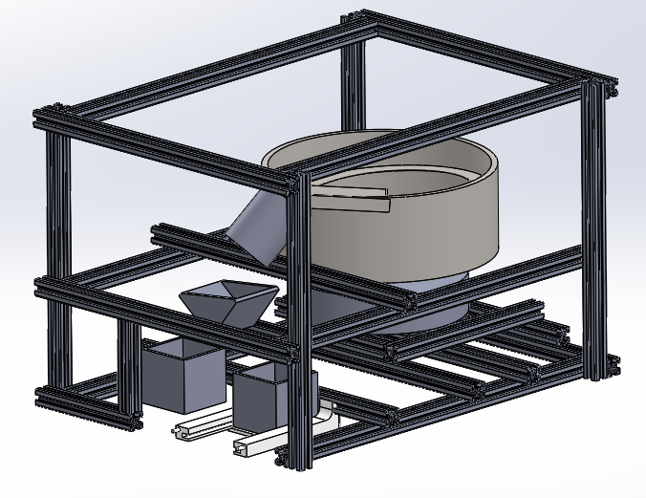What was also discarded from this idea was to have the option of a rejection bin for bad part counts. From figure 3, it is illustrated that the parts would fall into a staging cup. If the count was

Figure 3. Vibrating Bowl Design

wrong it was to dump the cup with a servo to the bin on the left. If the count is correct then

the bin would dispense to the right, where the operator could retrieve the parts. This failsafe was removed because we felt that we could get an accurate count consistently enough to that it would be less than useful.

After more research, we considered two more ideas. One used conveyor belts and limiters for part flow and the other used a set of rotating disks with slots to pick up parts one at a time and dispense them at the top of the bowl. These ideas where found from YouTube. The conveyor design used two belts and a limiters to organize and count parts[5-6-7]. The case feeder used a disk with part slots to isolate and orient shell casings as they are moved one at a time to the top of a 45 degree slope [4]. We chose the case feeder design with the bowl and disk, due to it being less complex, having components that could be easily calculated and we that the fabrication would not be too difficult. The concept was also more compact than the vibration bowl and the conveyor belt designs. We also liked how gravity was used to remove any extra parts caught by the machine. Figure 4 shows a model of our chosen design concept.

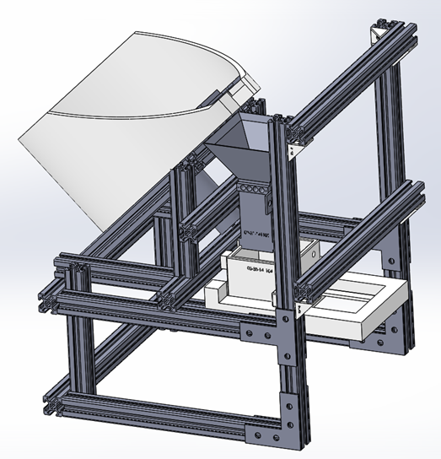

Figure 4. Rotating Disk Feeder

To hold the main population of parts on the disk and agitator, we knew our bowl had to have a volume that would hold the largest part volume but not completely fill the bowl. We also knew that the bowl would have to be able to move the longest screw. These dimensions influenced both our bowl size and slot dimensions at the top of the bowl and on the disks.

Originally we had hoped that we could print the bowl as one piece and the first bowl contained more ABS than what was necessary. A 3-D printer was expected to be used to make the bowl to ensure precision and because the printer would be able to fabricate our shape and eliminate extra fabrication processes with some other materials. The only thing the printer needs is material which is where the cost for making the parts is incurred. We first tried to eliminate some of the ABS material from the bowl by making the motor hole in the bowl wider. This changed or original plan to mount the motor directly to the bowl which would have made centering the motor shaft and assembly easier. We still had a high ABS volume for the bowl, in order to reduce the volume.

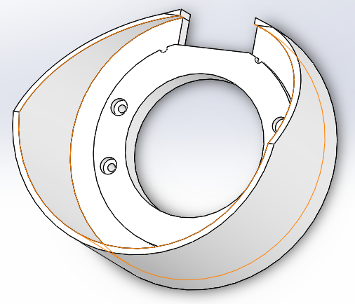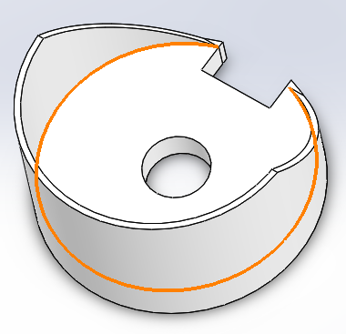

Figure 5. First Bowl Design Figure 6. Final Bowl Design

Additionally on the newer bowl a bolt pattern was included in the design to provide a mounting point for our bowl. We researched fasteners that would work for our design. By having the counter bore, the bowl can be fastened and the head of the fastener would be out of the way of any moving parts. Diameter for the threaded part of the bolt is 6mm to match the channel width on the 80/20 extrude. The counter bore itself is 13mm in diameter and 6.5 mm deep to contain the head of the bolt chosen. Figures 5 and 6 illustrate the changes of our bowl design from the first bowl concept to the final printed bowl concept.

During the mechanical process, we have utilized 3D printer for printing some of the major components of the machine. The material of these components is ABS, and the friction factor between ABS is 0.1. The tolerance of the printer is 0.2mm, so we need to consider the tolerance when designing the size of the components[9]. In order to account for this tolerance, we fist made each part with perfect fit measurements. We could then build the CAD structure perfectly. When we needed make the part, the part model was then reduced by the printer’stolerance at the interfacing edges of part. The part would be sent as a STL file to the printer, where it would be created[9]. Most of our printed parts where 100% filled. This helped to improve the strength of the part due to no gaps existing within the part to cause internal stress concentrations[16].

When considering motor design and comparing that design to our model, we found that the motor packaging was interfering with the frame, bin and funnel designs. We had to reposition the motor to ensure that the motor was not going to contact any other components and cause a problem. To do this we mounted the motor by making a mounting plate that would hold the motor in place from the threaded holes on the gearbox. The plate could then be mounted

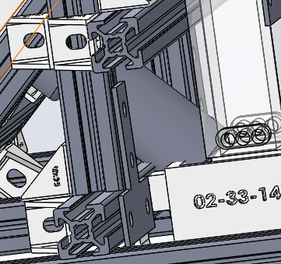

Figure 7. Motor Interference with Bin and Funnel

to the 80/20 extrude just underneath the bowl [14]. We found that doing this allowed for tight motor packaging and good positioning under the bowl. To take care of the rest of the position issue we extended the vertical member of the slope and relocated the horizontal mounting position. This kept our bowl angle at 45 degrees pulled the motor away from the funnel and other components. Figure 8 shows how the motor was successfully mounted. Figure 9, models the plate design used to mount the motor to the frame.

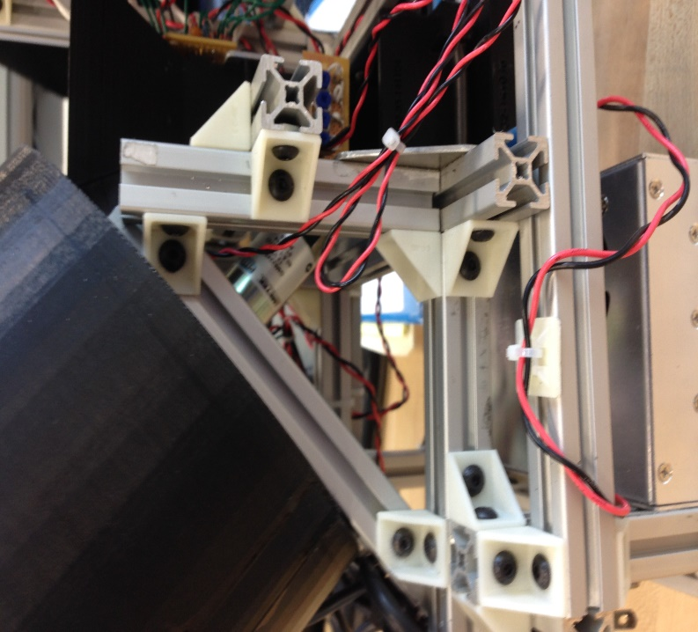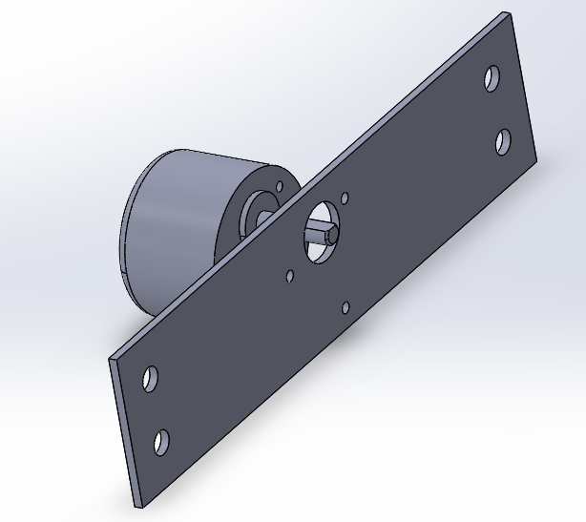

Figure 8. Motor in the Actual Machine Figure 9. Motor Plate Model

Our next change was to the presentation bin and slider. Pegs where added to the front face of the bin and back face of the slider to allow an anchoring point for our springs. We drilled a hole through the center of the pegs to push some of the spring wire through and wrap it. This creates a good anchor that displays the springs in a more professional manor. We also created location pegs for the front of the slider. In order to make the assembly work, the bin had to be riding along inner rails of the slider. To do this, an end needed to be open for assembly purposes. Once these parts where installed together, an end piece to the slider was fitted on the end pegs and glued into place. This ensured that the operator would have something to push on and it prevented the assembly from coming apart. Figure 10 displays the pegs used for attaching the springs to the assembly.

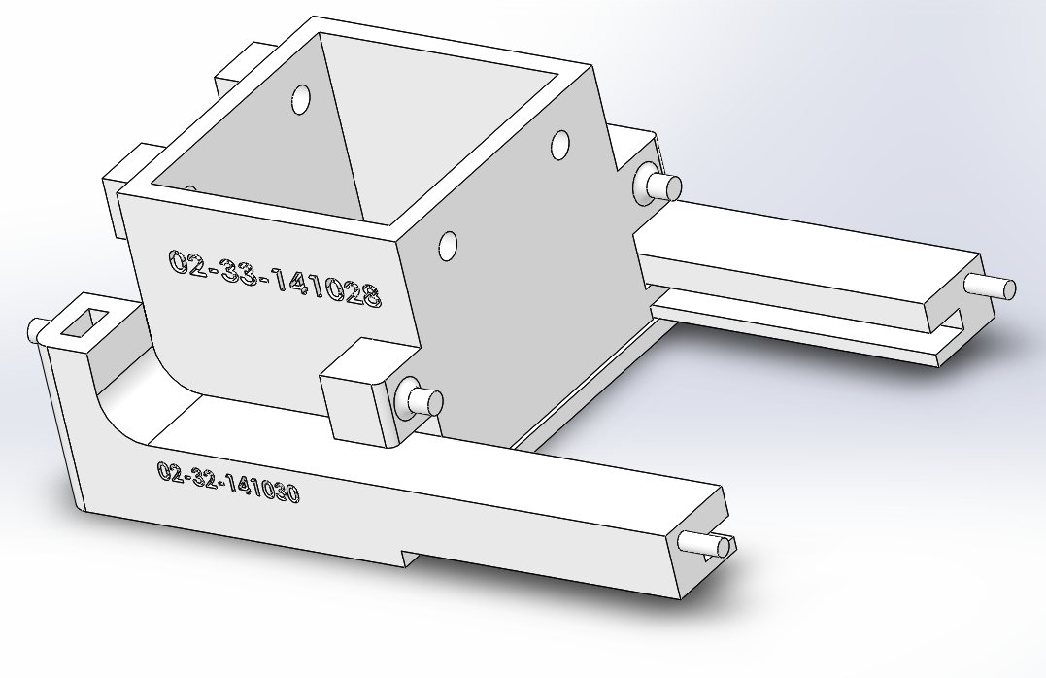

Figure 10. Bin and Slider Design

Back offsets on the bin where placed due to potential motor fitting issues. The offset also places the bin a little closer to the operator and provides more clearance between the operators hand and the power supply located in the lower rear part of the machine. The offset is the extra material behind the bin in figure 10. The holes in the front where added to provide another mounting point to the frame. This additional mounting point was needed to distribute the force from the falling fasteners and greatly reduce moment created by the operator pushing on the slider. This reinforced the bin so that it would not brake under normal operation.

Due to considering the costs of making 6 different plates. We tried to print off a thin master disk design. The Master disk would have inserts that were to lock into the plate and have cut out slots that would only allow for one fastener to sit in the slot at a time. To prevent the insert from falling out, we used a puzzle feature and an edge made into the master disk to prevent the insert from coming out.

After printing the master disk and some inserts we started experimenting with the machine. Due to centripetal force, the inserts wanted to lift off of the disk. Parts would also fall down the face of the disk and cause the insert to pop out due to vibration. This lead us to look for a counter measure to the inserts popping out. We also discovered in the process that some of our insert slot designs where too large. This allowed for conditions where two parts could be moved up the incline drop into the bin at the same time with one slot. This was unacceptable because the intended function of each insert slot was to grab and isolate one part at a time.

The original reason for a single disk design with inserts was to keep the printing cost low. However, after printing some parts through our group leader’s work, a company called 3-M, we could print each of our disks for a low price of $2.50. This is a huge improvement over the professor Latcha’s printer, where we estimated that individual disks had a cost range of $20-$45[]. With this in mind, it made more sense to apply updated slot designs to individual full disks.Wewould solve both problems at once; the slot designs would be reprinted and optimized, and there would be no more inserts to pop out. Everything would be strong, have the same bonded material, and the wheel surface about each slot location is uniform.

After some testing, it was noted that the shaft used for turning the disks was experiencing too much wear. We had assembled and super glued the shaft key piece to the original motor shaft.

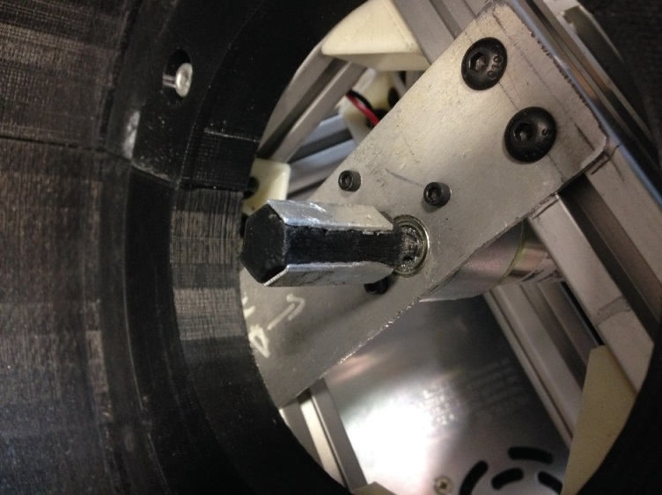

Figure 11. Modified Shaft

To fix this issue, we took 1mm thick sheet aluminum and cut it into 3, 7x25mm pieces to apply it to 3 faces of our hexagonal motor shaft as seen in Figure 11. After super gluing these strengthening pieces into place, the disks would not fit on the shaft anymore due to the new pieces. To adjust the disks, an exacto-knife was used to carve out parts of the disk to fit it onto the key piece. Our addition prevented further wear on the shaft piece and prevented us from stripping out the key or the disk centers.

Our last experimental modification was the addition of an agitator that was placed and superglued in at the edge of the 10mm nuts, 4mm nuts, 50mm cap head screws, and drywall screws. This additional isolator was to grab and mix the nuts in the bowl such that they would be

oriented with their face on the disk, making them easier to drop into the disk slots. During testing with the nuts, it was observed that the last nuts would land and orient themselves on the back 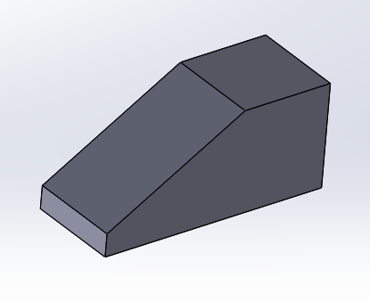wall of the bowl. The nuts would then slide and spin as the disk rotated underneath them.

Figure 12. Additional Agitator Model

They would avoid the correct orientation to be picked up by the slots. To fix this the new agitator was applied with the flat side in the direction of rotation to grab and prevent “nut run”. This agitator would carry a few nuts towards the top and dump them so they would be in the correct orientation.For the bolts and screws, it was observed that more agitation was needed to allow for the disk to pick up the parts. Due to the geometry of the screws, parts often landed in an incorrect

orientation for the slot. With only a flat disk, the mass of parts would slide over the plate with little agitation to properly orient the screws. The additional agitator was installed with the ramp end facing the direction of rotation to create a wedge effect when it hit the parts. By using this wedge to bump the screws, parts are agitated more aggressively and frequently. This caused the parts to be reoriented more often, increasing the chances of a screw being correctly oriented for the wheel slots.

Part Simulation

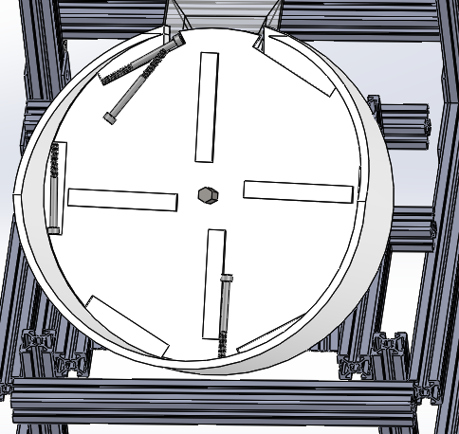When we got some of our first CAD models assembled, we wanted to see how our disk designs would theoretically work. To do this, a motion analysis was set up using Solid Works [15]. At the time we used disks with agitators that were large compared to the final disks and we used rectangular slots that were oversized by 1 mm in both width and length to

Figure 13. Snap Shot of 50mm Cap Screw Simulation

simulate 50mm cap screws as seen in Figure 13. To simulate 10mm hex nuts we applied the same additional 1mm to the diameter of a more circular slot. To get the geometry of each part, we used a part file provided from Mcmaster-Carr[12].

This allowed us to drop in a close simulation of each part. It also provided information about how the bolts would contact each other, allowing us to check for to see if thread lock might become an issue later on. Each simulation used a constant motor speed of 20 rpm. At the time we were still not certain of speed needed for each part, so 20 rpm was a good estimate at a universal speed. We noted that the Solid Works calculator was straining to calculate the motion of parts in the machine. This was an issue due because 1 second of simulation at times took up to 1.5 hours

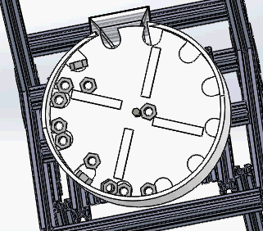to compute. We needed to turn down the number of times the integrator checked the math on the

Figure 14. 10mm Nut Simulation

model. The contact accuracy was also lowered for faster calculation times. The worse problem with simulation calculation is when the computer would hit a singularity in the math model that would not be computed correctly. When this happened the calculation would immediately stop leaving only a partial simulation. To try to solve this problem we tried step by step animation and browsed the help menu for ways to solve the calculationerror [8-15]. Solid works web site was little help, but from a tutorial we picked up on how to handle most of the motion controls which helped us control the simulations [8]. If more simulation was needed, we would have to adjust the options and begin the long wait again. To help prevent this, 10 or less fasteners were used in simulations as seen in Figure 14.

The simulations compared to the actual part movement within the machine where generally correct. Most of the part movement fit the overall movement of parts in the bowl. The way that the disks picked up the fastener and the way that the fasteners were agitated was fairly accurate. For early stage analysis, simulations were valuable to prove that the method of the machine could work.

The difference between the simulations and the actual machine came in the detailed part movement and scenarios. A computer will only be able to calculate a few given scenarios and conditions. In the real machine, thousands of part orientation and contact points exist. The downside that we had with simulating is that the computer did not want to compute large quantities of parts being simulated in the machine. When more parts are in the machine, part behavior may change. We also found jamming conditions and slot issues while testing the actual machine that the simulation did not pick up. This just shows that a computer can get close but is not a substitute for live tests.

**Part FEAs**

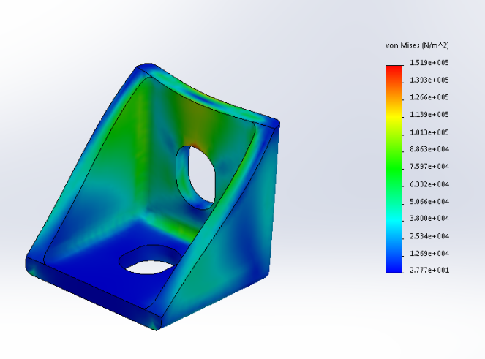 In order to analyze the forces on parts of our machine, we performed a few finite element analysis for parts that we believed would see the most stress. The we knew the majority of the frame being made from 80/20 extruded aluminum and having a tensile strength of 36,000 psi lead us to feel safe about our material selection for the frame[14]. We also made L-brackets and T-Brackets from plate aluminum with the same tensile strength. Our ABS plastic was had a yield

Figure 15. 90 Bracket Unit FEA

strength of 246ksi at minimum [9]. The most important number to recognize for us was that our printed parts act as composites. The glue layer between the composite was the weakest factor with shear strength of 4500 psi if we put the part into a isolated stress loading condition where the direct stress is applied 90 degrees from the direction of the layers[16-9].For the following components we were not worried about this being an issue due to the parts having a large enough surface area to dissipate the weight of 50 M10 socket head screws, the heaviest part at 3 pounds [12].

The 90 bracket was a part we were concerned when coming up with the concept of our design. We would use at least 1 bracket to connect beams together and ultimately hold key components of the frame, bowl, and user interface into place. These brackets had to be small and able to be applied at multiple angles. The first FEA performed was to prove that under a unit stress the design concept for our bracket would stand up to the weight of other components and the fasteners under fully loaded conditions. As seen in the figure 15, the maximum stress from applying a 1 newton force to the bracket resulted in as stress of 151.9kpa or 22.03 psi[17]. Form this we also got a deflection of .06299 mm. We did some prototyping and testing. During the test

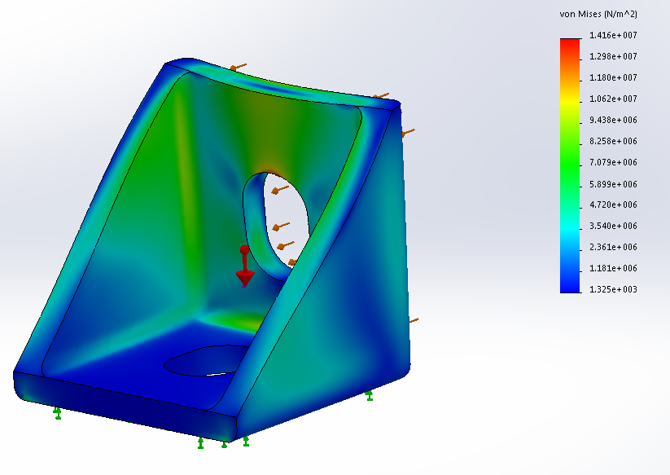the part held 20 pounds without breaking, but extreme deflection was observed. We then ran an FEA at 20lbs and found that at 2x the weight of the machine, the part will experience

Figure 16. 90 Bracket FEA with 20lbs

5.6mm of strain and be taking on 2053.7 psi. By having this number still under the half the needed stress to pull the bonding apart and be at 2x the machine weight proved that the bracket could be small, lightweight and strong. To make this FEA as seen in figure 16, gravity was applied, then the base was fix and the load was applied to the second part interface.

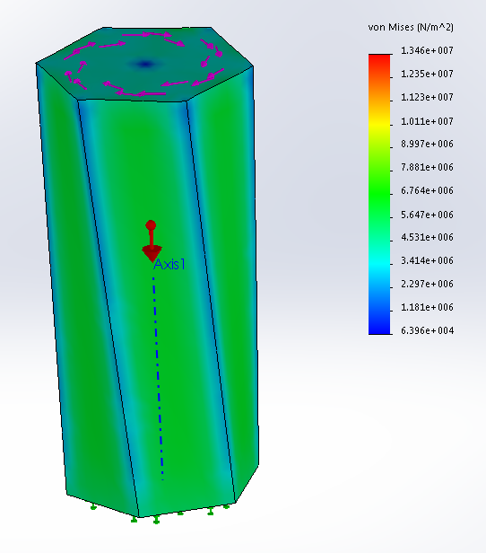

Figure 17. Unit Shaft FEA

The second FEA was to prove that the motor shaft would be able to handle the amount of shear stress being applied from the interactions between the motor and the weighted plate.In order to get an idea of how the shaft would react, an FEA was created to test the unit resistance of 1Nm on the shaft face. In Figure 17, we can see how the torque was applied to the shaft piece. By fixing one end and twisting the other, we could get an idea of how the shaft would react if the disk was twisting from the end. This was the most extreme condition for the shaft location. The stress experienced was less than the stress experienced was high but not out of the range of the ABS material. The shaft was created vertically, so the applied stress in this case acts as an isolated strain condition. This condition allows us to use the strength of the ABS material in our calculation. W still took the adhesive shear strength to be our deciding factor for the part due to it having the lowest strength of 4500 psi [9].

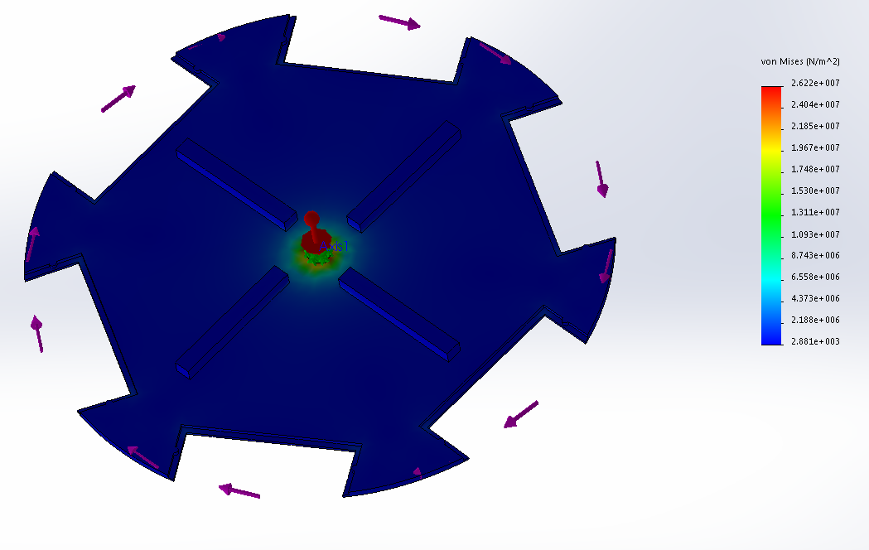From the results of this FEA, it is observed that the stress on the shaft is 1.346 x 10^7 Pa or 1952.2 psi [17]. This is almost half of the shear strength of the adhesive, and the load is 1Nm. The largest theoretical load would occur if all of the largest fasteners where applied at 1 point on

Figure 18. Unit Plate FEA

the edge of the disk. The force that the shaft would see is 1489.6 Nm. This would be a problem if the entire load was a point load, applied directly at the edge of the disk and there if there was no 45 degree angle. What helped our FEA result even more was the fact that the torque was not being applied at the end of the shaft making deflection much less and the structure was much stiffer. This restored confidence in our shaft design. We did not consider wear effects though and would eventually apply aluminum to 3 shaft faces to strengthen the shaft surface enough to handle the torque.

The above FEA is of one of the master disk that were where intending to use early on. The FEA is disturbing, however the disks when applied did not act in this manner. This matches similar results that we found with our unit FEA on the shaft. Our stress around the shaft interface is 2.622 X 10^7 pa or 3802.9 psi [17]. This is due to the low thickness around the shaft head and the full load being applied directly to the plate without any angle. By keying out more material with our later disk design, we turned the shaft into more of a gear design. This created more area for the torque to be applied over. Also after testing for some time, we found that the damaging effects on the material where less severe than what we had first thought.

These where the materials that we felt needed an FEA due to the forces applied to them. Once we increased the strength of our motor shaft with aluminum strips, the area of contact became greater and reduced the stress for the larger parts. The rest of the structure was made with durability in mind and created out of aluminum or thicker material, making the other components less likely to deform or fail.

Testing

Since most of the mechanical designs are printed by 3D printer, it is important to perfect each part before printing. Though the test, the glued bowl is strong enough to hold fifty parts. It did not tend to separate apart. The size of the disk could just fit into the bowl, and the gap between the bowl and the disk is small. In this case, the parts could not stuck. The agitators on the disk could stirred the part in a high efficiency. The gap of the disk could only allow one parts getting into, and it just as same as what we assumed.

As we analyzed the idea of price and making parts fit together. It was found that making parts that used thin ABS printed parts where cheaper than our original parts. We became more comfortable with working with ABS after we tested the prototyped design for a 90 corner bracket. The idea for this design was altered from working aluminum brackets for sale on the web at Mcmaster-Carr.com or 80/20.com[12,14]. The brackets used gussets to strengthen the joint. Some used multiple screw locations to stiffen the joint and increase contact area. Since our machine weight is 10 pounds, we felt that with multiple applications of a smaller light weight bracket could be used to have high strength with minimal space. We also removed tabs that fit into slotted sections of the 80/20. This allowed us to use our bracket for a wider range of applications including parts on an angle, which the shelf bought brackets would not be able to do.

In order to ensure that this application would work, we tested the bracket design. A small sample of 10 90 corner brackets was printed in order to test the bracket design strength. In order to get an idea on how the bracket might perform, we used FEA from Solid works. By comparing an FEA with 1N applied to a mounting face and the other mounting face fixed, we could predict the deflection of the part under loading. This could be compared to the test results in order to estimate how the brackets will perform.

To conduct the experiment, four brackets where secured to a 2x4 using Philips head sheet metal screws. The brackets where up and down in orientation and attached to the edge of the 2x4. The 2x4 was then clamped to a table using a C-clamp to prevent it from moving off the table. By two hooks and string, weight was applied to each of the brackets. The weights had known measurement labels. This test did not need to be very precise, due to the predicted weight that one bracket was to lift was approximately 5lbs. The test was stopped at 22lbs because the part was deformed, there was no need to go higher when only 5lbs was a comfortable working weight of the machine and the design has multiple double brackets applied at the joints.

The other major test performed early on was the verification of our spring stock. From Mcmaster-Car’s specifications, the spring rate constant could be found by dividing the length of the spring by a ratio of 1.1 [12].

To test the spring constant we hung a weight of 120g from 60mm of spring off the edge of the table. We then measured the change in spring length and matched it to a hand calculation.

$F=kd$ (9)

Where we can solve for k from the given ratio, and break F into mass times acceleration. We then get the following equation.

$\frac{Ma}{d}=k=L/1.1$ (10)

After when we compared the result we confirmed that the spring ratio was accurate and we could expect a value of 2.5 pound force per spring when applied to our assembly.

Final Assembly

In order to assemble the machine, we first built up the frame by cutting the correct length of the beam connect them by screwing the brackets. Then we put the bowl on the 45-angle frame to figure out the position of motor, as well as the height of the funnel. After fixing the motor by motor plate and fixing the funnel by funnel plate, we fixed the bowl by putting a disk on the bowl. In this way, the disk could help adjusting the position of the bowl. Moreover, the bowl and the shaft could have the same center. Then the dispenser and the electrical parts were easily fixed on the frame.

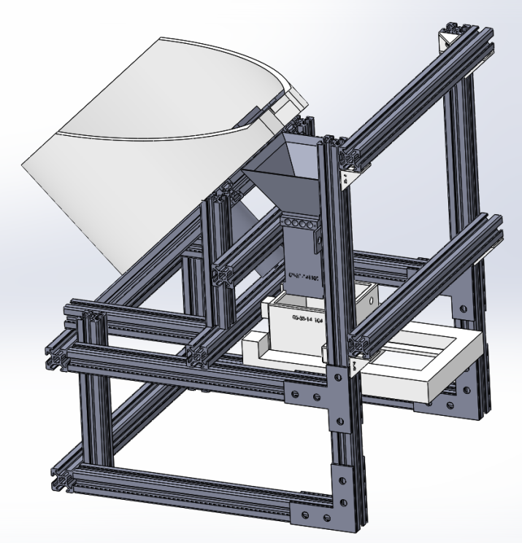

Figure 19. Finalized CAD Model of Machine Concept

Our finalized machine design is shown above in figure 19. As shown above, about fifty unorganized parts will be dropped into the bowl. The motor that is fixed on the frame will rotate a wheel inside the bowl. Depends on the types of the parts, different wheel and different inserts of the bowl will be utilized. The unorganized parts will be rotated into the gaps of the wheel, and sent to the top of the bowl. Then they will drop into the funnel through a big gap on the top of the bowl. There will be eight pairs of IR sensors, which attached on the side of the funnel, waiting for detecting the number and speed of the parts. After controlling the speed and the number of the parts, the rotating process will stop, and the correct number of parts will drop into the presentation bin. The waiting hand can easily push the slider that underneath the presentation bin, and receive the parts when the machine is ready.

The size of the total design including both mechanical and the electronical stuff is $270mm×300mm×350mm$. Because we fixed everything together on the stable frame by proper size of screws and nuts, the whole machine is easy to carry and move.

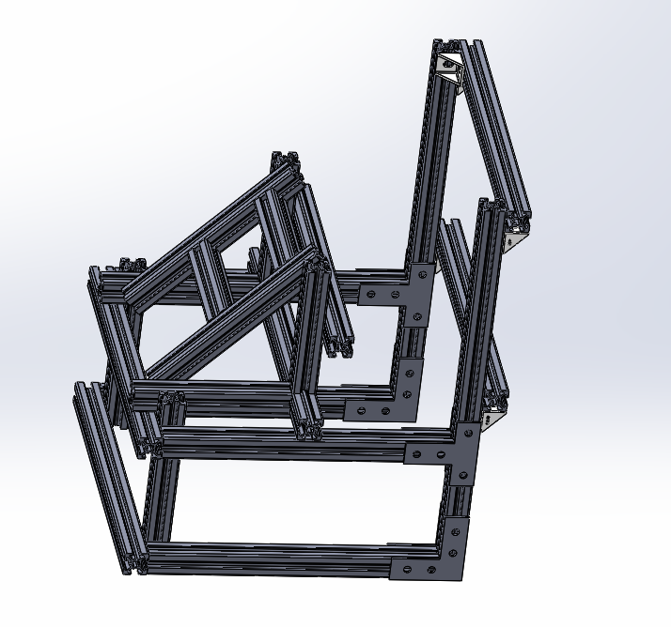

Figure 20. The Supporting Frame for the Total Design

The figure above shows the frame design of our machine. After the roughly drawing the outline of each component, we thought about the method to connect each component. It will be more delicate and easily to use if we can figure out a proper way to hold the whole machine. According to the mechanical and electrical components, we utilize the 8020 Aluminum alloy. It is bought from…. We cut it into different size, and put them together by utilize the proper fastener. Each component is fix one frame by using the nuts and screw. If there is any part that needs to be changed, we can easily change the position, length and angle between the beams, and mount the screw at the proper place that we want.

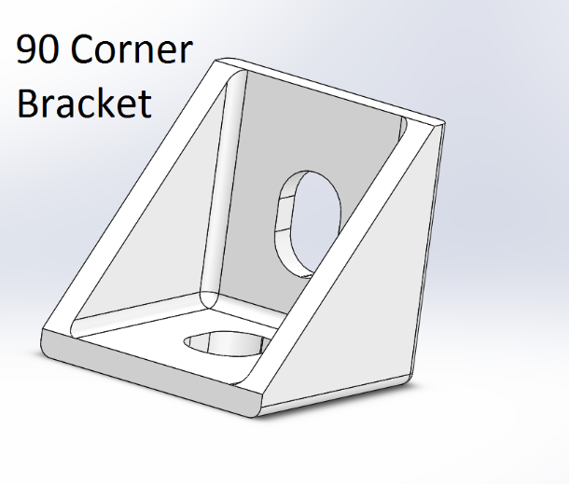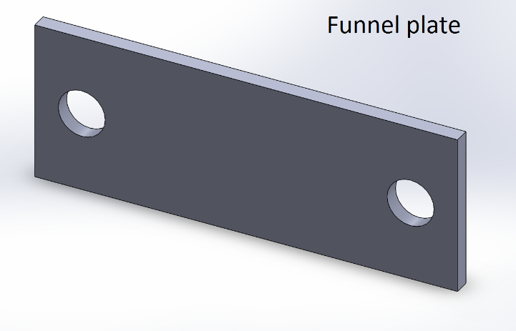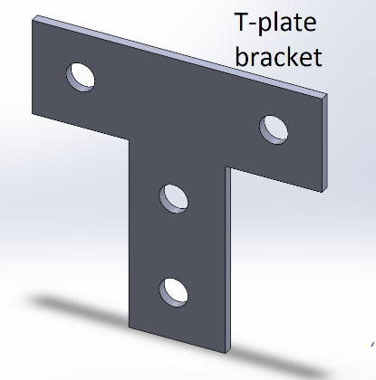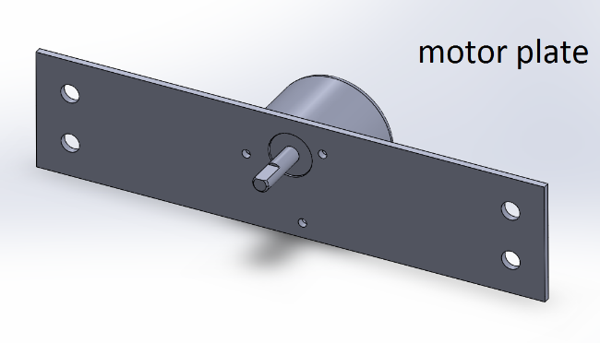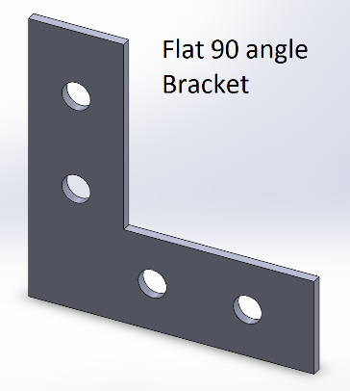

Figure 21. The Brackets and plates

The Brackets and plates in figure 21 are used to fix the fames and components. Except for fixing the motor, the diameter of the bolt that we utilized is 5mm. The bolt for the motor is 1mm depends on the size of the hole of the motor itself. The 90corner bracket is printed by 3D printer, and we utilize about forty of them to fasten the frames. Thus, the frame is stable and hard to move when we using and testing the machine in the working process. The other Brackets and plates are built in steel in the machine shop. The diameters of the holes are 6mm, and we smoothed the edge of the brackets and the plates in case of hurting by the sharp places. Moreover, because the brackets and the plats is easy to change and move by bolts and nuts, the convenience of this design is obvious. For example, we can adjust the position of the motor plate in order to fasten the motor right in the center of the bowl.

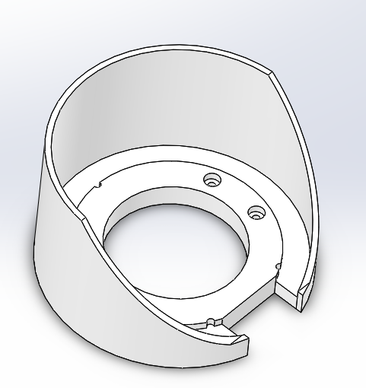

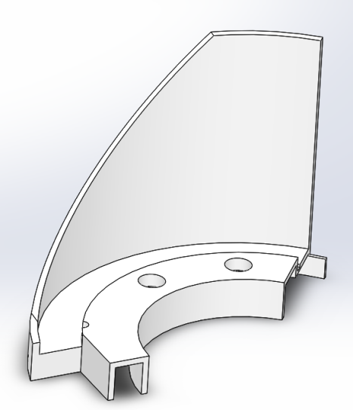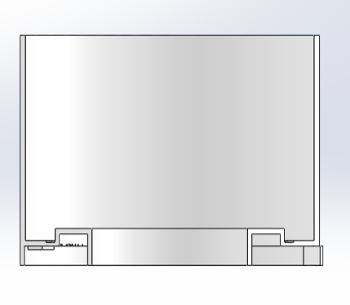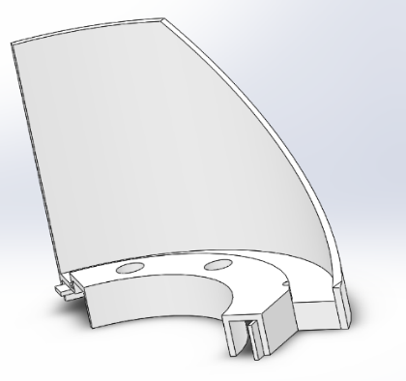

Figure 22. The Bowl and the Three Divided Parts of the Bowl That Used for Printing.

The figure shown above is the bowl. It is held up on the frame with an angel of 45 degree. The bowl is utilized to hold the bowl inserts, wheels and all the unorganized parts. Also, there is a cuboid gap on the side of the bowl, and the size is big enough for carrying all six types of parts. It allows the parts dropping into the funnel. The internal diameter of the bowl is 202cm, and the thickness of the wall is 4mm. For saving the cost of the bowl, we cut off a lot of material from the bottom. Because the bowl was not in a regular shape, we decided to use 3D printer. The size of the bowl was larger than the capability of the printer, so we printed it by dividing it into three parts. Then the left, center, and right part of the bowl were glued together. The glued bowl was firm during the test, and never tried to break apart.

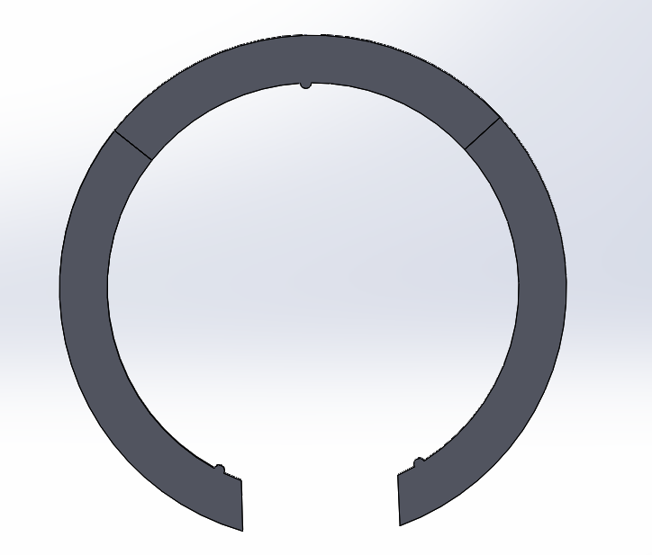

Figure 23. The Inserts of the Bowl

As shown above, the shape of the bowl inserts is same as the shape of the gap inside the bowl. The three small semi-circle are used to fix the position of the inserts. In this case, the rings will not move randomly inside the boal gap. Because the thickness of six parts are different, we have designed four different thicknesses of the rings including 6mm, 4.5mm, and . Then the thickness of the gap can be changed by easily putting the rings in. The size of the ring is larger than the capability size of the printer. Since we used 3D printer to print ABS material inserts, we divided each one into three part.

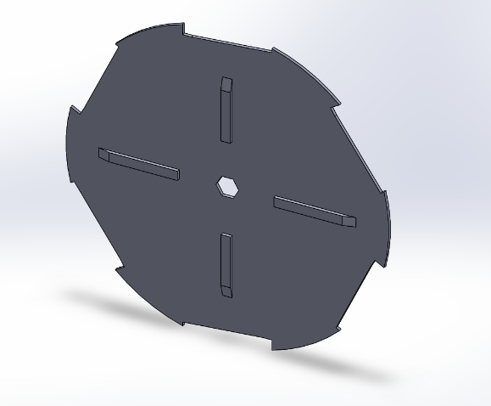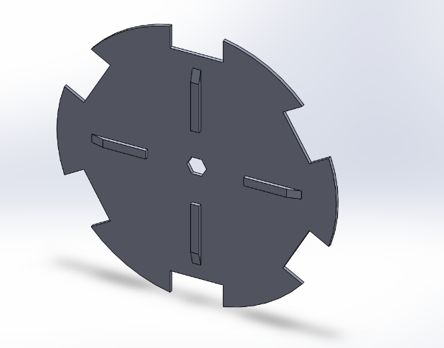

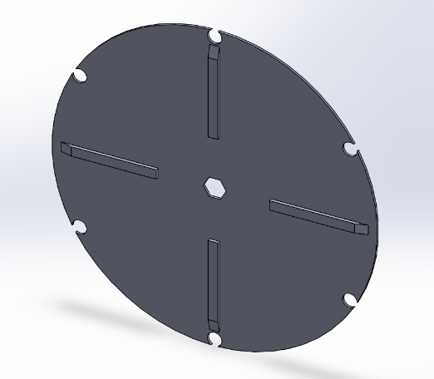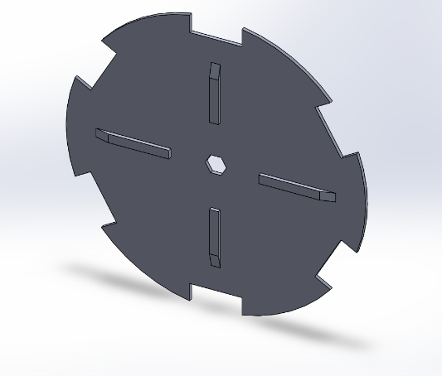

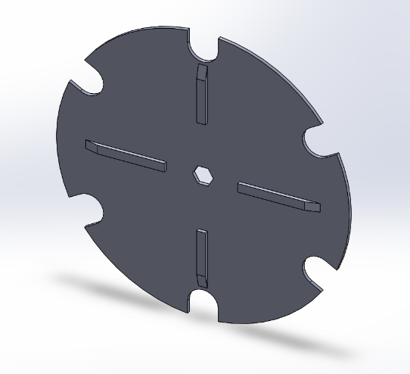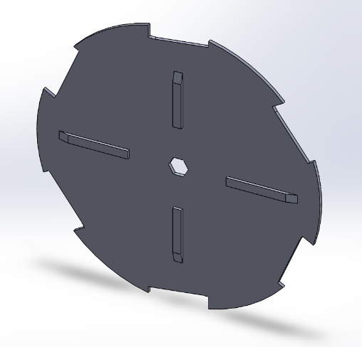

Figure 24. Six types of wheels

The figure shown above is the wheels for each part. As we know, there are six kind of parts that might be sorted. The inserts of the bowl can used to change the thickness of the gap, and the wheels can change the outline shape of the parts. Because we don’t need to care about the thickness when designing the wheel, the thicknesses of the wheels are 2mm. Thus, we save a lot of material by printing the thin wheels. There are four agitators on each of the wheels. It is used to stir the parts. Because there are about fifty parts that need to be organized, it is important to make them apart, and they can easily drop into the gaps. All the six wheels are printed by 3D printer. Also, the shaft will be attached to the middle of the wheel in order to send the power for rotation process.

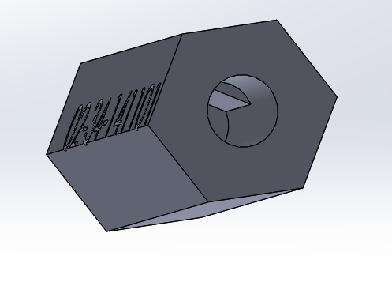

Figure 25. The shaft

The shaft is used to connect the motor and the wheel. Since the hole of the shaft is designed according to the size of the motor, the motor can easily attached to the hole of the shaft. Then, we super glued the shaft and motor, and the shaft will be more stable. The external shape of the shaft can just fit into the wheel. In this way, the wheel can rotate in the same rotational speed while the motor rotating, and the motor can easily control the rotating process of the wheels. The shaft is built by 3D printing.

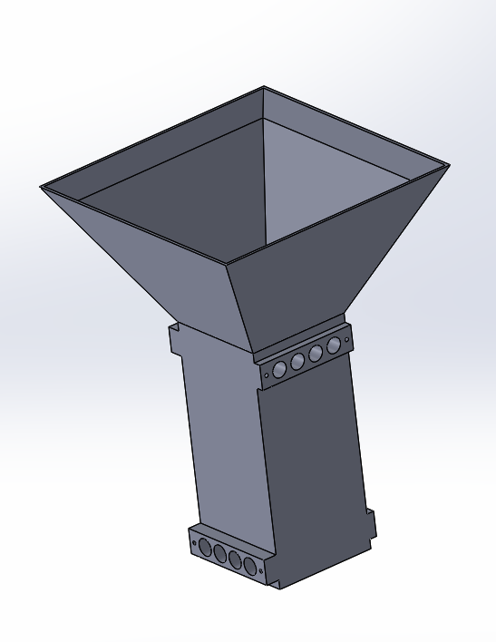

Figure 26. Funnel

The funnel with IR sensors is an important part to counting the number of the parts. As shown above, the upper part of the funnel is right below the gap of the bowl, and the size of the entrance is enough for all the parts to drop in. Then the sensors will detect the parts. Eight pairs of sensors are attached to the hole of the funnel in two levels. Once the part is detected, the electronic screen will add the number, and the motor will receive the feedback of the speed. In this case, the motor can better control the speed of machine. In order to cut accurate size of the sensor hole, we printed funnel by 3D printer.

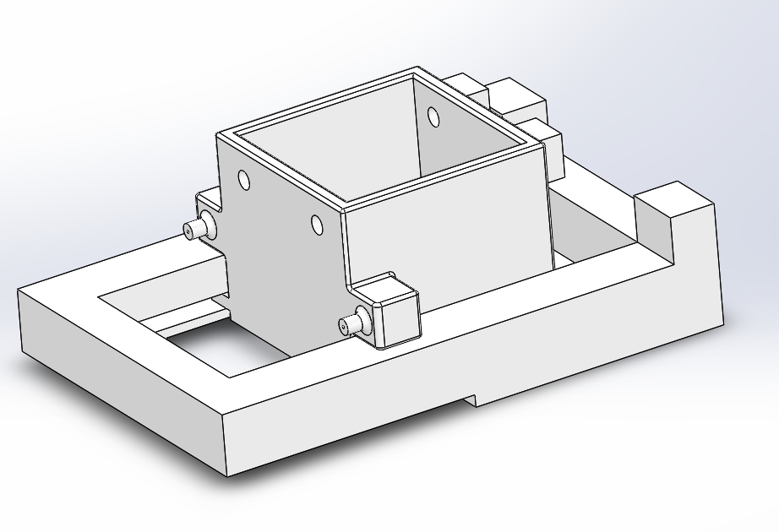

Figure 27. Presentation bin and push slider

As shown above, the parts will drop into the presentation bin after going through the funnel. When the machine is ready, the machine will stop rotating, and the correct number of parts will be stored in the presentation bin. Then, the awaiting hand can easily push the slider underneath, and receive all the needed parts. Both presentation bin and push slider are made by 3D printer, and the material is ABS plastic. The presentation bin is fixed on the frame, and it holds the slider as while. In order to connect presentation bin and slider, and control the position of the push slider, there are two springs on the each side of the dispenser. In this way, the spring will extend when the push slider is pushed, and the spring can pull the slider back to the normal position when the force disappears.

To fasten together the frame of the assembly we used a veriety of screw and a set of Din 562 standard square nuts [5]. The nuts were thin enough to fit into the channels of the 80/20 extruded alluminum on a flat edge. When turned with a screw, the nut corners would hit the channel and begin to tighten the joint. All of our frame fasteners worked with these nut.

The most common fastener we used in the design was a 6mm M5 button head cap screw [12]. This screw was just long enough that we put 3.5 mm between the mounting surfaces of the nut and screw head [14]. This fastener was picked because it would not bottom out in the 80/20 channels. The team used these fasteners for all structural frame construction. These screws held together the 90 degree brackets and the other plate brackets to make the frame joints. They also hold the motor plate and the power supply plate to the frame.

Any other fasteners that we applied on the major mechanical componenets of the machine were picked because they were able to reach the bottom of the 80/20 extrude channel and still have the head of the screw compressing the mounting surface of the part being mounted. Each of these screws where an M5 socket head cap screw with a 0.8 thread pitch to match the Din 562 standard square frame nut[5-12]. All fasteners made for part attachment to the frame had a threaded shaft diameter of 5mm to fit in the channel of the 80/20 extrude [14].

We used 80/20 extruded alluminum for all frame aspects of the machine. This matierial as visually apealing and professional. A 20 series profile was selceted by researching on the web [14]. From the main site, we found that even the smaller 20 sereries with a profile of 20mm x 20mm still had a tensile strength of 36,000 psi [14]. This was valuable to us because due to the strength we would not have to worry about the material breaking. For our calcuated length we have 4.5 meters on the machine. We found through granger, we could get the 20 series alluminum at lengths of 4 meters [13]. Each 4 meter piecewas $41.85 making the framing fairly cheap but professional. The extrude was handy for mounting components and could be cut to any desired length. It was relitivly easy to work with and assemble. When the wiring needed to be mounted, the framework was easy to stick things on or wrap zip ties around to hold wires. The 6mm open slots fit an appopriate range of screws and the nuts we found worked well in the channels [5-12].

**Electrical/Electronic Subsystems**

Sensor Design Concept

For detective and counting system what we considered and followed is shown in the flow chart

Parts detected

Microcontroller

Counting

parts

Detector

Counting completed feedback

Figure 28.

The primary thing we did was figuring out the detective method. After thoughtful consideration, we got the result thatlaser is stable and reliable, but more expensive. Pressure sensor is hard too. Motion sensor is not sensitive enough to detect small parts. IR sensor is perfect working on short distance detection, sensitive and stable. Moreover, it is cheaper enough. Therefore, it became to our final option.

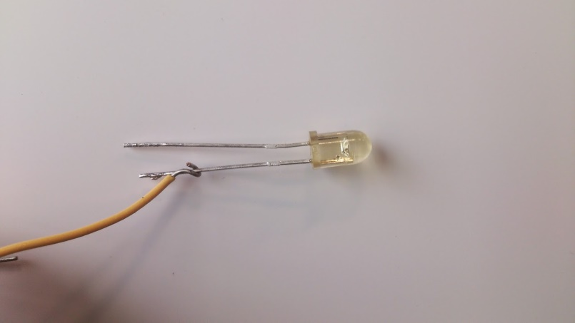

Figure 29 IR led op290

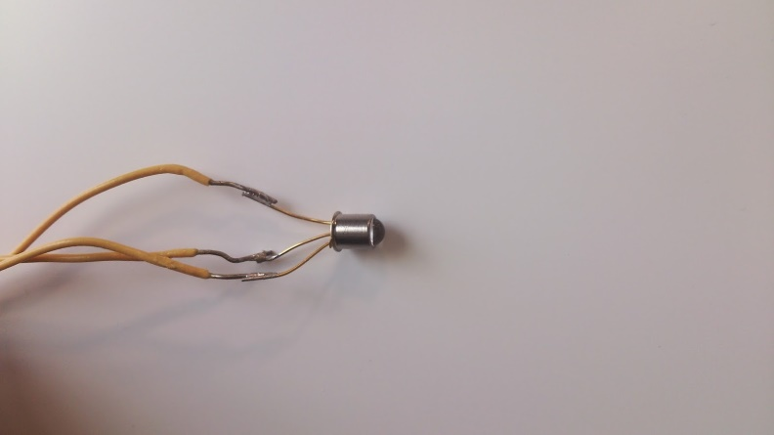

Figure 30 phototransistor OP830SL

Shown in the figure 29, 30 are our IR led and phototransistor. It illustrates infrared detection system which is used through our design. They essentially create a “beam” of IR light between two locations and provide us with a digital “Low” when there is nothing to block it, because when transistor bias, collector pole will pull down to the ground. Inversely, when parts block the “beam” of IR light, BE junction stop work. Thus, collector pole will pull up and the output gets a digital “high”. This efficient system proved to be useful in our design where we needed to know that a part had passed by, such as in counting parts and starting/stopping the machine. During IED and phototransistor selection, angle displacement and

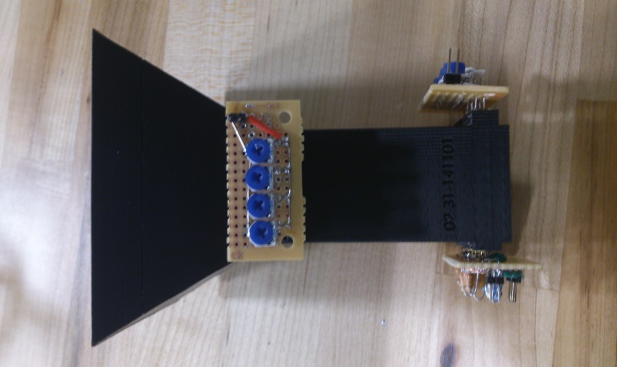

Figure 31 funnel and detection system

The concept sketch of entire system is shown in figure 31. 8 sensors are separated into two layers, 4 sensors parallel with each other to form a cross-section. Two layers have 90 degree difference on angle that if considered from 3 dimensions perspective we can get agrid structure. This structure provided our counting system a most safety detective environment. The sensors are fixed in the funnel which can isolate the sensors from external environment. In this case, we minimized the external disturbing.

**IR LED and Phototransistor Design Validation**

**Essential Specifications**

To validate the selection of the IR LED and phototransistor components used in sensing the presence of the parts, several essential specifications were identified to be tested on the real circuit. First, the IR LED needed to provide a sufficient amount of lumens to the phototransistor in order to switch the device between the on and off state. Secondly, the phototransistor needed to have a narrow receiving angle so that the phototransistor would only receive the light from its respective IR LED. The phototransistor should also have a rise time significantly smaller than the time that the part with the smallest width would take to cross the path of the light beam. With these considerations in mind, we tested the sensor circuit to ensure the phototransistor and IR LED combination would fit our application.

**Luminance**

To test that the IR LED could sufficiently switch the state of the transistor, we constructed the circuit in Figure 1 and checked the output voltage with and without blocking light at varying distances. Using helping hands as seen in Figure 2, the phototransistor and IR LED were held steadily while the distance was varied. The IR LED easily controlled the state of the phototransistor. In fact, the IR LED was capable of switching the state of the transistor at distances over 40mm, which is nearly double the distance used in this application. As a result, we concluded that the IR LED and phototransistor met our first criterion.



Figure 32. A schematic of the IR LED and phototransistor circuit.



Figure 33. The apparatus for holding the IR LED and phototransistor system.

**Receiving Angle**

To test the receiving angle, the same test circuit used in the first test was constructed and the helping hands were similarly used. However, in this test, the lateral position of the IR LED was varied instead of the distance. During this test, we found that phototransistor was extremely sensitive to the lateral position of the IR LED. Through this test we determined that at the maximum output of lumens from the LED, the phototransistor could be switched on and off from a 3mm deviation from the centerline of the transistor. In comparison, the centerline of each pair will be at least 5mm away from its neighbor. Furthermore, we found that decreasing the amount of lumens output by the LED reduced the maximum deviation. When installed in the real funnel, the LEDs’ brightness can be further tuned to prevent any interference. As a result, we concluded that the reception angle of the phototransistor is more than sufficient for avoiding interference in the application’s configuration.

**Rise Time**

In order to evaluate the rise time of the circuit, we needed to identify the minimum rise time necessary for the transistor circuit. We identified that the rise time needed to sufficiently small so that the output voltage would reach greater than +3V before the object has completely passed through the path of the beam. To compute a nominal value of this, we examined the kinematics of the situation. We identified that the object would be in freefall and the shortest time interval for detection would occur when the object is at its greatest velocity. With these considerations, we computed the objects velocity at the bottom of the funnel. We found the velocity to be approximately 2.2m/s. Next, using the width of the smallest part, we computed the minimum time interval for detection. We computed the minimum time interval for detection to be approximately 4ms. As a result, we defined that the maximum acceptable rise time must be less than 4ms.

The rise time of the phototransistor was evaluated using the circuit depicted in Figure 1 and the physical configuration depicted in Figure 2. We used a 33kΩ and 11kΩ resistors for RC and RB, respectively, and 1nF and 47nF capacitors for CCE and CCB respectively. By blocking the light we evaluated the response of the phototransistor. Figure 34 displays the rise time of the sensor as observed by the oscilloscope using these values. As can be seen the rise time of the circuit is approximately 10ms, which is unacceptable by the criterion previously established.



Figure 34. The waveform of the initial test of the phototransistor's rise time.

Since the configuration did not meet standards, we needed to adjust the time constant of the circuit. Initially, we decreased the value of CCE which decreases the time constant. We changed the value of the capacitor to 1nF. The voltage output after the test as observed by the oscilloscope is depicted below in Figure 35. As can be seen in the figure, changing this capacitor did not affect the rise time significantly.



Figure 35. The waveform of the rise time due to changing CCE.

Since CCE did not affect the rise time significantly, we investigated the affect of CCB on the time constant. We quickly realized that this capacitor, which is in parallel with the Miller Capacitance of the transistor, has a much greater effect of the time constant of the circuit due to the current gain of the transistor, β. As a result, we changed CCE to 47pF and removed CCB from the circuit. As a result, the circuit is configured as appears in Figure 36. We tested the circuit under this configuration and observed the rise time to be significantly improved to 350μs, as can be seen in Figure 37. Since the rise time is significantly lower than the criteria established earlier, the circuit meets our specifications.



Figure 36. The schematic of the IR LED and phototransistor circuit removing CCB.



Figure 37. The waveform of the rise time due to removing CCB.

Implementation of circuit design

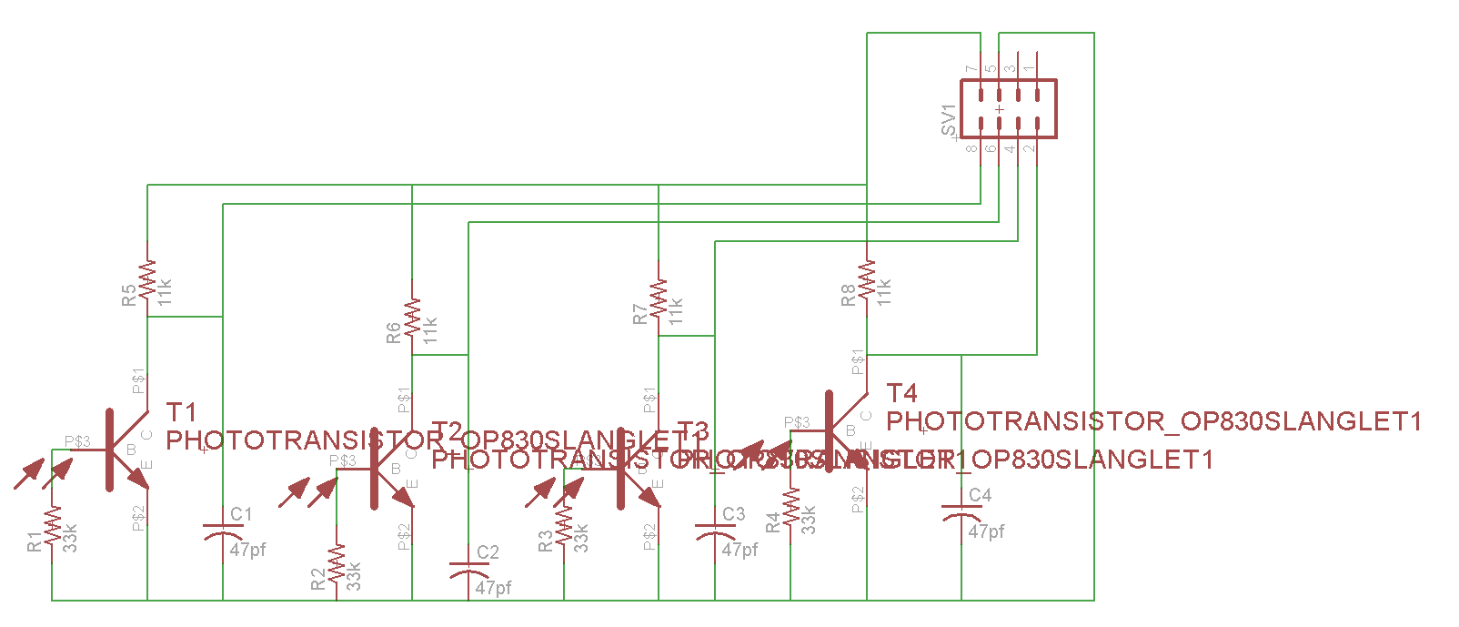

Figure 38 Circuit sketch of receive side for PCB

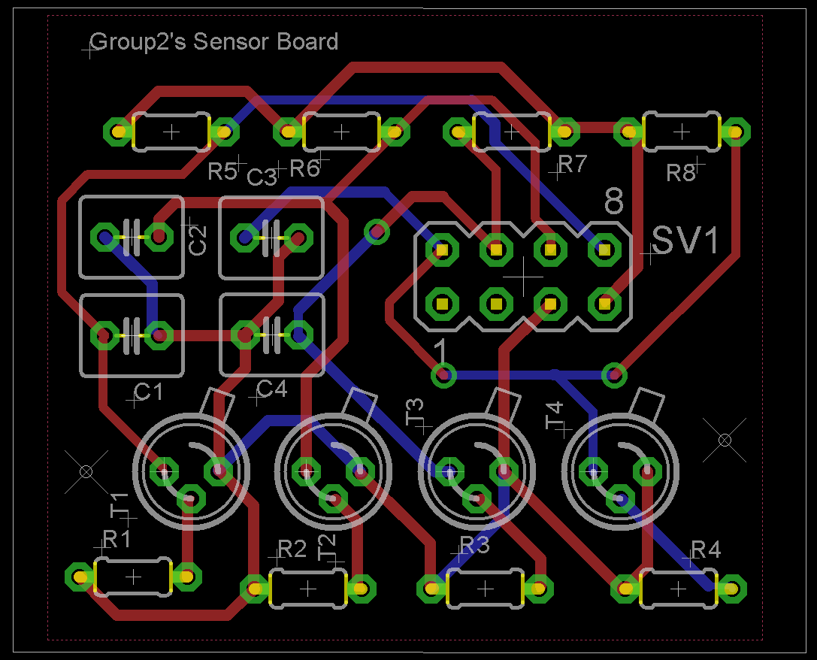

Figure 39 PCB for Receiver side

Shown in figure 38 and 39 are our PCB board design for receiver circuit. The size of board is 42mm*36mm. The interval between each transistor follows the design specification of funnel. Although to print PCB board will be costly, using the PCB can avoid the wires exposure, which decreases the probability of error and block the interference from external environment. Besides, this design optimized the layout of our product, and in order to systematize our product to satisfy the concept of simplification and efficiency, PCB is the best choice for us.However, due to the PCB board need nearly a week's time, but we couldn’t wait for that long. So, finally we changed our mind to solder this board by using common circuit board.

HMI Implementation

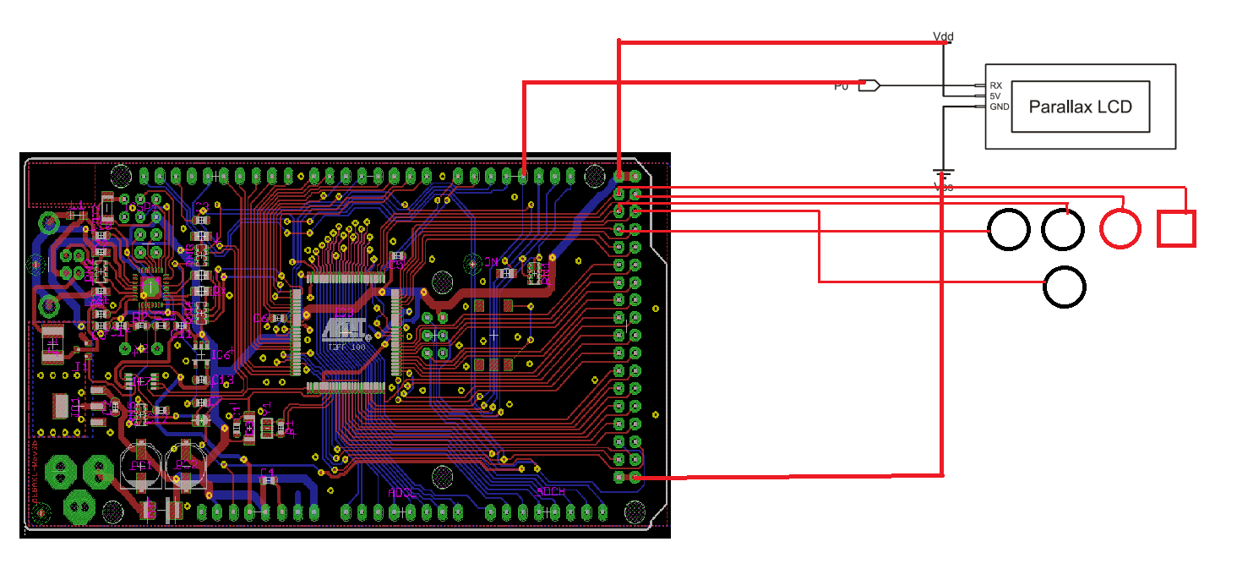

Figure 40. Wires connection of interface

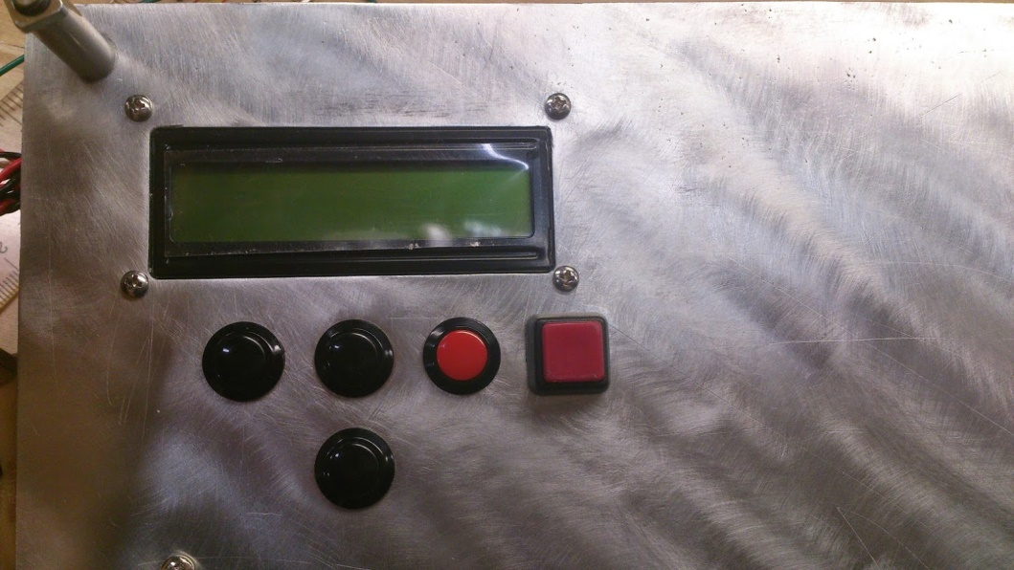

Figure 41 interface out looking

Shown in the figure 40 is wire connection of our interface design. The LCD which we chose is Parallax 27977 with serial interface. Serial interface will reduce the pins usage of Arduino board and also simplifies the coding part. The design of interface follows the idea of concise and high controllability. Five buttons corresponding to the functions: Start. Select, up, down and back which meet the requirements of our expectation to control our design working in order.

**Button debounce circuit**

It was necessary to incorporate a button de-bounce circuit into the design in order to keep the microcontroller from becoming confused due to residual noise from the contact bounce that occurs when a push button is momentarily pressed. The originally implemented circuit is shown in the figure below.

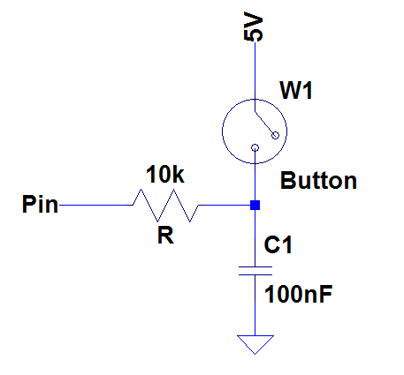

Figure 42. Active-high Button De-bounce circuit

During testing it was revealed that the capacitor, C1, tended to keep the pin voltage high even after the button was pressed and released, giving a false positive indication to the microcontroller and causing it to activate different menu commands when not requested. To mitigate this issue a 10h Ohm bleeder resistor was soldered in parallel to C1 to allow the voltage to “bleed-out” to ground after the button had been pressed and released.

**Motor Selection, Modeling, Analysis, and Discussion:**

Motor Selection and Mathematical Modeling

Given the mechanical requirements of the system that the motor be able to output at least 20 oz-in of torque, rotate at least 80 rpm, and fit within a form factor of no more than 37mm in diameter and 108mm in length, it was determined that the Pittman/Ametek 8224 DC servo motor and a G35A gearbox, with 60.5:1 gear ratio was an appropriate selection. The motor and gearbox specifications can be found in Appendix D.

In order to properly implement the Pittman/Ametek 8224 DC servo motor into the system design it was necessary to first conduct a control needs analysis on the motor. A mathematical model of the motor was derived based on Kirchhoff’s Voltage Law, Newton’s Second Law and the conservation of energy principle. The electro-mechanical model used below in figure 43 was taken from Gu, pg. 298[18] .

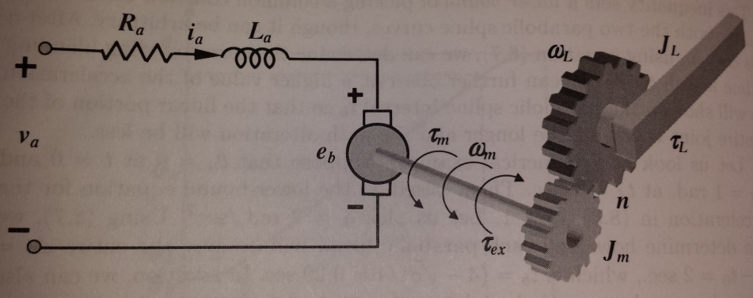

Figure 43. DC motor electro-mechanical model, taken from Gu[18]

Two simultaneous dynamic equations were produced from this model:

$$\left\{ \begin{aligned}L_{a}\left(\frac{di}{dt}\right)+R_{a}*i_{a}+e_{b}=v_{a} (11) \\ J_{m}\left(\frac{dω}{dt}\right)+B_{m}*ω_{m}+τ_{ex}=τ_{m} (12)\end{aligned}\right.$$

From this set of equations describing the dynamics of the system, the Laplace transform of the equations was taken and used to derive the block diagram for the system, with all of the forces contributed by the load such as the torque, mass moment of inertia and damping factor of the load, referred to the motor through the gearbox ratio.

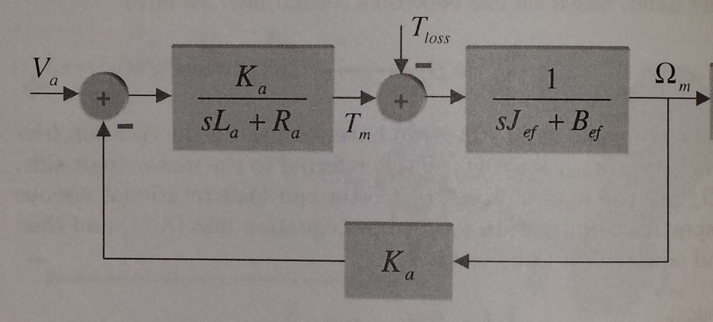

Figure 44. DC motor model block diagram, taken from Gu [18]

From this block diagram the transfer function for the system was derived:

$$G_{m}\left(s\right)=\frac{-TLs+R-K}{JLs^{2}+\left(JR+BL-KT\right)s+BR+K^{2}-RTK} (13)$$

The transfer function for the system was subsequently used in a MATLAB simulation to ascertain the resonant frequency, damping factor, and step response of the loaded motor system to understand the system stability and what kind of control scheme, if any where needed to be implemented. It is worth noting that the all the motor and load parameters necessary for the analysis was provided both by Pittman’s spec sheet and the mechanical analysis of the system, except for the damping factor due to the load. Before the simulation of the motor could be complete the damping factor due to the load had to be calculated based on experimental data.

Viscous Damping Experiment

The experiment to calculate the viscous damping factor of the load was set-up using an ammeter in series with the motor. The motor was powered from the on-board 12V power supply. The load due to the six different fastener types was tested, with the machine being fully loaded with all 50 of each fastener. The system was then allowed to run momentarily with the load as the steady-state current draw was observed and recorded in table 1.

|  |  |  |
| --- | --- | --- |
| **Part Type** | **Iteration** | **SS current (uA)** |
| 4 mm nut | 1 | 0.06 |
| 2 | 0.06 |
| 3 | 0.06 |
| 10 mm nut | 1 | 0.25 |
| 2 | 0.24 |
| 3 | 0.20 |
| 10x25 mm screw | 1 | 0.24 |
| 2 | 0.21 |
| 3 | 0.18 |
| 4x50mm screw | 1 | 0.09 |
| 2 | 0.08 |
| 3 | 0.07 |
| Drywall screw | 1 | 0.10 |
| 2 | 0.10 |
| 3 | 0.10 |
| Drywall anchor | 1 | 0.07 |
| 2 | 0.07 |
| 3 | 0.07 |

Table 1.

An average current was then calculated for each part type. This average current was used in conjunction with equation 14, taken from the *Pittman Servo Motor Application Notes* [19].

$$I=\frac{T_{l}+T_{m}}{k_{t}} (14)$$

Where *I* is the motor current, $T_{l}$ is the load torque, $T_{m}$ is the motor torque and $k_{t}$ is the torque constant of the motor, which in the SI units is equivalent to the voltage and motor constants[18]. The torque due to the load was referred to the motor via the gear-box and equation 15 was rearranged to find the torque on the motor produced by each disk and fastener type.

$T_{m}=\frac{I*k_{t}}{n+1} (15)$

From the torque calculation for each load, equation 16 from the Pittman application notes was used to calculate the rotational velocity of the motor shaft.

$$ω=\frac{-R_{t}}{k_{t}*k_{e}}*T_{l}+ \frac{E}{k_{e}}- \left(\frac{R_{t}}{k_{t}*k_{e}}\right)*T_{m} (16)$$

Given that Kt = Ke in the SI units and the load torque can be referred to the motor via the gear-box, equation 16 was rearranged to find the velocity of the motor shaft.

$$ω_{m}=\frac{E}{k_{m}}- \left(\frac{\left(n+1\right)*R_{t}*T_{m}}{k_{m}^{2}}\right) (17)$$

Once the motor shaft velocities were calculated for every load, the viscous damping factor due to the load was calculated from Newton’s Second Law, where the torque due to the moment of inertia died out at steady-state and could thus be rearranged:

$$B_{l}= \frac{τ_{m}-τ_{l}}{ω_{m}}- B_{m} (18)$$

After the different damping factors were calculated for each load an average of 0.0166 Nms/rad was found and used as the damping factor for the load in the transfer function of the system for the MATLAB simulation.

Motor Analysis and Discussion

Since the value for the damping factor due to the load was calculated it was then possible to simulate the step response to the motor and find the damping factor and resonant frequency for stability analysis. When the all of the motor and load parameters were entered into the model, the transfer function that resulted (figure 45) showed that there was a negative pole in the denominator, instantly implying that this system would be unstable and need a PID controller to correct this pole placed in the right-hand plane. The step response in figure 46 also confirmed this as the system tended to “blow-up” towards infinity in amplitude in response to a unity step input.

Transfer function:

-2.146e-006 s + 1.18

------------------------------------------

3.086e-009 s^2 - 3.077e-005 s + 7.046e-005

Figure 45. MATLAB generated TF

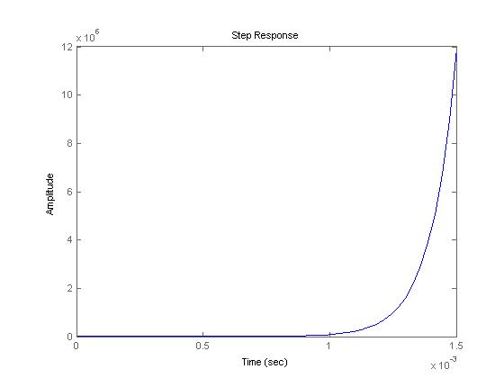

Figure 46. Step Response of Motor-Load System

An interesting note is that during the testing for the viscous damping experiment the load was overdriven by the motor so much that the longer the motor was allowed to run without control the more unstable the load became, throwing parts off of the machine and airborne in every direction, also causing the disk to become deformed. This was a serendipitous experience of analysis agreeing with empirical evidence.

Motor controller selection:

It was necessary to choose a motor controller that would allow bidirectional control of the gear-motor for the sake of braking when the system was paused by the user, control the speed of the motor by PWM output of the microcontroller and be able to give a current sense feedback to the microcontroller for closed-loop feedback control. Such a controller was found with the PololuMD01B-VNH2SP30 Motor Driver Carrier.

**Power Analysis and Supply Selection:**

It was necessary to analyze the electrical power needs of the system during the early design phase. The on-board power supply was selected based on these needs. The analysis began by looking at what sub-systems would require the most electrical power and what the peak power requirement of those systems would be. The motor had a peak current draw at stall torque of 10.3 amps according to the specifications sheet. At 12 volts maximum operating voltage and 10.3 amps of current, drawing upon Ohm’s Law the motor power, $P_{m}$,requirement was found to be 123.6 Watts.

Next, the power requirements for the Arduino microcontroller board were analyzed. The Arduino Mega 2560 that was used in our design incorporated ON Semiconductor’s NCP11175T50T3G voltage regulator and according to the data sheet for the regulator found at alldatasheet.com [20], the equation to calculate power dissipation of the regulator given an ambient temperature was:

$$P_{μ}=\frac{T_{jmax}- T_{A}}{R_{θJA}} (19)$$

Where $T_{jmax}$ was the maximum die junction temperature of the IC, $T_{A}$, the ambient temperature and $R_{θJA}$ the minimum sized pad’s junction to ambient thermal resistance. The power dissipation calculated was 1.92 W. Given that the operating voltage would be 12 V, this only allowed the Arduino’s voltage regulator to source a maximum of 160 mA, a different power bus would have to be sought to power the 5V devices. Then given the simulation results from the sensor circuit, the photodiodes and phototransistors would cause a maximum current draw on the system of 119mA. Since these devices were required to be powered from a 5V bus, the total power required, $P_{s}$, would be 1.6W. Given all of the power dissipated across the different electrical loads on the system, the total power required was calculated using KVL and conservation of energy as:

$$P_{total}=P_{m}+P_{μ}+P_{s} (20)$$

This was calculated to be 127.12 W. And the total current draw was found to be 10.8 A. Given that it is always desirable in power systems to have twice the power dissipation available than is needed by the application, a 12V power supply that could source 21.6 A of continuous current would have been desirable. Given our constraint to what would be commercially available, the closest power supply to our needs was a 12V, 30 A power supply that offered 360W of power dissipation, giving us a safety factor of 2.8.

5V Bus Analysis

To choose how to power the 5V bus, the current consumption of the array was analyzed. Initially, the on-board regulator of the Arduino Mega was considered. The feasibility of this on-board voltage regulator was analyzed. According to the schematics and datasheets, the voltage regulator for the Arduino Mega can source approximately 500mA [21]. The sensor array was estimated to draw a maximum of 200mA per sensor. The total maximum current draw for the entire sensor array was estimated to be 1.6A. As a result, the on-board voltage regulator on the Arduino would not be able to source the necessary current for the sensor array. Two Fairchild Semiconductor LM7805 linear regulators were chosen to create the 5V bus. According to the datasheet, each regulator is capable of sourcing 1A under room temperatures [REF2]. These regulators were installed in parallel. The effect of heat production as a result to dissipating the necessary current within the regulator was investigated since these devices’ output voltages drop with the temperature. To test the thermal characteristics, the sensor arrays were connected to the voltage regulators and the output voltage was monitored. With this experiment the voltage was observed to drop 1mV/second as the components’ temperatures increased. The voltage eventually dropped as low as 4.85V. As a result, a heat sink and active cooling solution would need to be installed with the regulators. After installing the cooling solutions the regulators maintained a constant 4.96V output voltage and remained at room temperature. Below is a figure of the voltage regulators and active cooling solution.

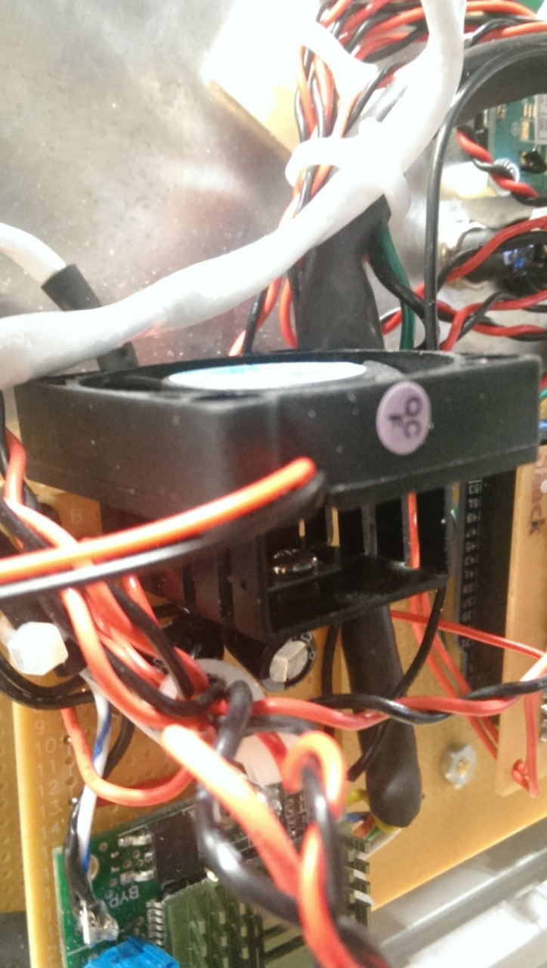

Figure 47. Linear voltage regulator with active cooling

Arduino Pinout

During the course of the design and as the complexity of interfacing the components to the microcontroller grew, it was necessary to document which pins which component was connected to. The pinout diagram was used to help keep track of this. Here in Figure X is the pin layout for the Arduino Mega2560 board that was used in our project.For the motor driver we used pins 15, 46, and 50-53. This was decided by looking at the motor drive Pololu MD01B. Pin 46 was the PWM, pin 15 was the analog pin, and 50-53 were digital pins. The sensors used pins 30 to 37which were all digital pins. The buttons used digital pins 22-29 with 28-29 being assigned a byte for the buttons. The LCD used digital pins 18 (TX1) and 19(RX1). The status LEDs used pin 38 and 39 and lastly the dispense sensor used digital pin 40.

BUTTONS

SENSORS

MOTOR DRIVER

LCD

STATUS LEDS

DISPENSE SENSOR

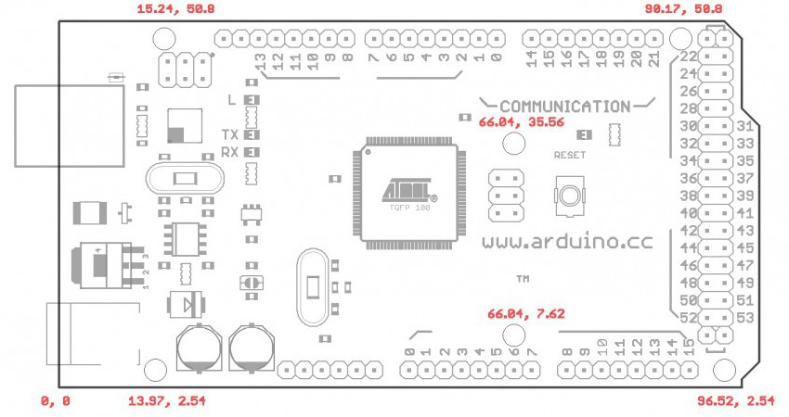

Figure 48. Arduino Pin-Out

**Computer/Software Subsystem:**

Counting Code

The IR sensor emits a LOW signal while the sensors are on. Once the sensor is broken by the part that is falling, the signal emits HIGH. The pins that were used for the sensors were from PIN C which are digital pins. The pins that were used were PCO to PC7. There were eight pins chosen because there were eight sensors used. Four sensors were put at the top of the funnel and four sensors towards the bottom of the funnel. This algorithm used double detection. While the part is falling through the funnel it breaks the first sensor which lets the code know that the top sensor is HIGH by using bitwise AND, and at that moment it counts one. When the second sensor gets broken by the same part falling still, that same thing occurs to the second sensor. It lets the code know that the bottom sensor is now HIGH and it counts now goes up to two. When that part is done going through and the count is up to two, now the modulus comes in play where the number that was received is divided by two and the code looks at the remainder. If the remained is 0 then the main count that is used for the LCD display goes up by one. A small delay was also added for upper and lower sensors after the initial count was received before being able to read the next count again for the next part coming down.

For reading the longer parts there was a separate algorithm written along the same lines of the algorithm that is described above. It only used a single detection. When the longer part falls through the upper and lower sensors the bitwise OR operation is used for the upper and lower bits to get the count updated that way. That also updates the LCD. The longer delay is used to make sure the part is out of the shoot so the counter won’t keep on counting quicker than it should be and allows time for the signal sensor to go back to low. The loops will continue until no more parts fall through.

# LCD Control Code

In order to control the LCD, a finite state machine was implemented. Each state would represent the set of text that the LCD should display. Below is a diagram of the finite state machine. The LCD state machine helps transition the machine through the user input and interfaces with the motor controller, sensor controller, and LED controller. To accompany the state machine, a data structure was defined for the LCD controller, which would store the data for the selected part, selected amount, the confirmation flag, and the current state of the LCD.

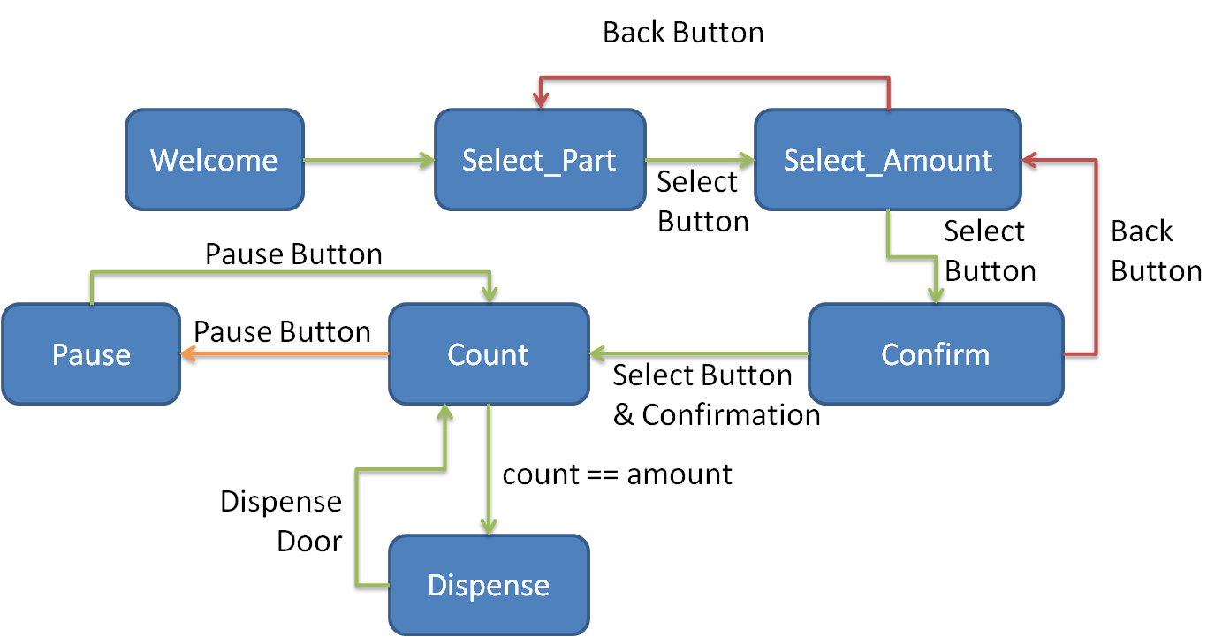

Figure 49. LCD State Diagram

The system starts in the Welcome state where it displays a greeting to the user. Next, the system transitions into the Select_Part state where it displays the currently selected part and waits for the user to confirm the selection or change the selection. Once the user confirms the selection, the machine transitions into the Select_Amount state. In the Select_Amount state, the system displays the quantity of parts the machine will dispense and will wait for the user to change the quantity or confirm the quantity displayed. In this state, the user can also choose to return to the Select_Amount state if an error has been made. When the user has confirmed the amount in the Select_Amount state, the system will transition into a Confirm state, where the user may confirm that all selections are correct or return to previous screens to make adjustments to the selection. Once confirmation is received, the system will enter the Count state, where the system will begin motor actuation, accept input from the sensors, and blink the green LED. From the Count state, user can transition to the Pause state where the actuation will be stopped. Otherwise, the system will remain in the Count state until the parts counted is equal to the amount selected. Once this occurs, the system will transition into the Dispense state. In this state, the system waits for the user to dispense the parts. When the system senses that it dispenses the parts, the system will loop back into the count state. The machine will repeat the loop from Count to Dispense until the user powers off the machine.

|  |  |
| --- | --- |
| IMAG0289 | IMAG0282 |
| A | B |
| IMAG0283 | IMAG0284 |
| C | D |
| IMAG0285 | IMAG0286 |
| E | F |
| IMAG0287 | |
| G | |

# Motor Control Code

To control the motor, a software PID controller was implemented. The open source Arduino PID Library was selected to implement the controller in code [23]. In order to use the controller, several parameters must be set up. First, the current sense output from the integrated H-bridge must be sampled. The on-board 10-bit ADC was used to sample the analog voltage pin. The ADC of the Arduino Mega was tested to function at a sampling time of 200μs. However, sampling the current sense pin every loop at this sampling period would interfere with the ability to sample the IR sensors at an effectively high rate. As a result, the prescaler on the microcontroller was changed from 128 to 16 within the code to create a sufficiently low sampling period. After changing the prescaler, the sampling period was lowered to 20 μs. At this sampling period, there would be no interference with the IR sensors.

In addition to adjusting the sampling frequency of the microcontroller, the full ADC’s resolution was clearly not being utilized. The current sense pin on the H-bridge circuit outputs a voltage proportional to the current in the motor. The datasheet represents the relationship as follows:

$V_{CS}=I_{a}*K$ (21)

Where $K$ is the proportionality constant and has a value of 0.13V/A. Using the stall current, the max output voltage on the current sense pin was calculated to be 1.34V. However, under normal conditions the motor was empirically determined to draw less than .1mA. Also, the resolution at the lower voltage levels was determined to be significantly more important than the low of resolution for voltages above 1.1V. When inspecting the voltage reference options, the default voltage reference used by the Arduino was found to be 5V. The microcontroller also features three other options for references. These references include an external input, 2.56V internal, and 1.1V internal reference. As a result, the 1.1V reference was selected and implemented in software to use the maximum resolution for the ADC, which gives the ADC a minimum voltage step of 1.07mV.

Similarly, the sampling mechanism for the motor needed to be determined. Since the pulse width modulation signal cause ripples in the current sense signal, the direct ADC reading was not used as the reading would fluctuate significantly. Instead, the peak of the ripples was used. By using the peak, a common comparison could take place to determine the state of the system from one time sample to the next. The peak detection process involved sampling the analog signal for 200 data points. The sample size was determined to be acceptable since the time to collect these samples would allow for multiple waves to be observed. From these data points, the peak was determined using a basic peak detection algorithm. With this reading, the system can be observed and controlled by the designed control system.

Next, the PID output calculation interval needed to be selected. Much like the ADC sampling period, recalculating the PID output too often would result in interference with the IR sensors. Through empirical trials, it was determined that a recalculation interval of less than 40ms would prevent the IR sensors from detecting parts falling down the funnel. As a result, the PID output calculation interval was set to be 50ms.

With these parameters selected, the PID parameters computed in the Matlab simulation can be verified (Appendix C). Initially, Kp was set to 100, Ki was set to 2.5, and Kd was set to 0.095. Using these theoretical parameters, the system exhibited clear oscillations with the angular velocity of the motor. Observing the current sense signal also confirmed these observations. Consequently, the parameters needed to be tuned empirically. Using the serial interface with the microcontroller, the measured peak current was viewed on the lab computer. In the tests, it was determined that a Kp greater than 1 would result in excessive oscillations with the peak current. With this observation, the Kp was set to 0.8, which was the value determined to give the most consistent oscillations. Next, the Kd parameter was increased until the steady oscillations were mitigated and the overshoot disturbances in the peak current due to manual was reduced. The Kd constant was determined empirically to be 0.005. Lastly, the Ki term was used to eliminate the offset between the set point and the current reading. Through this method of calibration, the Kp, Ki, and Kd constants were determined to be 0.8, 0.01, and 0.005, respectively.

After running many parts through the system, it was determined that a jam mitigation mechanism was necessary. Using the current sense signal, conditional logic was implemented to detect a jam and take control of the motor if the scenario occurred. Using the serial interface and the lab computer, the current sense signal was read during a jam scenario. With this reading, a threshold was developed to differentiate between normal operation and a possible jam scenario. After obtaining the ability to detect a jam, the way in which to control the motor in the case of a jam was investigated. By changing the direction of the motor and actuating the motor for short periods of time, the jamming conditions appeared to be effectively fixed. With this observation, the “Jitter” jam mitigation mechanism was developed. Using experiments the number of “jitters” the parts needed to receive was determined to be five. After integrating the control strategy into the system, the mechanism was further tested. The testing revealed that it successfully solved the failure case with the exception of the case in which the dry wall screw’s head would slide in between the bowl and the plate. However, this problem was fixed by using a thicker bowl insert.

**Discussion:**

Technical Discussion

In completing the design for the parts counter, the system meets all the design specifications introduced in the project proposal. First, the design is adjustable to all six different parts specified (refer requirement FR-1 in Appendix E). The system physically as well as electronically adapts to each part by changing the plate and controlling the motor speed. Next, the system was designed in a self contained frame that is relatively portable and simple to configure (refer requirement AR-1 in Appendix E). The components were packaged in a minimal form factor with minimal space reserved for maintenance access. The implemented system was capable of dispensing parts in varying amount up to 6 and cycling indefinitely (refer requirement FR-2 and CR-2 in Appendix E). Through the HMI panel, the system meets the requirements of system adjustability by allow the user to change the number of parts to be dispensed per cycle (refer requirement FR-3 in Appendix E). Additionally, the bowl design was tested to accommodate twice the quantity of parts needed to be processed at a time, satisfying the accommodation of size of parts requirement (refer requirement FR-1 and FR-7 in Appendix E). The system was empirically tested through the competition and practice runs that the system has an average dispense time of less than 30 seconds while maintaining an accuracy of almost 100%, satisfying the dispense time requirement and accuracy requirement (refer requirement CR-1 and CR-3 in Appendix E). The delivery mechanism was effectively designed to hold six of each part until the user dispenses the parts. Through a mechanical delivery system, the system dispenses the quantity of parts virtually instantaneously directly into the hand of the user. These features satisfy the delivery mechanism and method of parts storage requirements (refer requirement FR-5 and FR-6 in Appendix E). As can be seen by these examples, the implemented system meets and in several cases exceeds the initial system requirements of the system.

The implementation of the system was not without challenges and hurdles during the integration phase of the system. Within the electromechanical assembly of the motor, motor shaft, and plate, the design experienced two specific failures. First, the mounting mechanism initially needed front face and rear mounting screws on the motor. When installing the read mounting screws on the motor, the motor experienced a mechanical defect in which the screws could be driven too far into the assembly. As a result, the screws cracked the brush of the motor when significant load torque was applied when testing the motor. To mitigate this problem, the rear screws were eliminated from the motor completely. In addition to the motor mounting issue, the shaft experienced a critical failure. When the shaft experienced significant loading in the case of the large bolts and nuts, the plastic corners on the hexagonal shaft stripped out completely. The shaft would spin without turning the plate causing the overall system to fail. To solve this problem, aluminum sheet metal was applied to three sides of the shaft to prevent the strip failure. After testing this solution the shaft no longer failed in this manner.

In addition to mechanical hurdles, the electrical integration experienced many roadblocks as well. First, the integration of the motor into the system interfered with the 5 volt bus. The pulse width modulated signal driving the motor caused noise spikes of greater than 5V to appear on the 5V regulated line. These spikes interfered with the operation of the sensors, causing false positives to occur. To mitigate this problem, a filtering capacitor was placed across the motor to smooth out the pulse width modulated signal. After installing the filter, the voltage on the 5V bus was measured through the oscilloscope and these spikes were reduced to less than 10mV, which would no longer interfere with the sensors. Lastly, after installing the sensor modules, one set of modules was demonstrated to intermittently fail. As a result, the count was completely inaccurate. The subsystem could not be fixed in hardware since the component was permanently fastened to the funnel. To eliminate this faulty sensor, the software was modified so that it would ignore the readings by the sensor module. Fortunately, the sensor design implemented redundant sensor modules, which allowed the failure of one sensor module to not impact the overall functionality of the system. By masking out the lower sensor module, the system returned to counting in its original, perfectly accurate state. As can be seen by these examples, the overall system integration phase was not without hiccups with the interaction between subsystems.

**Professional and Societal Context**

Engineering Standards

The search for applicable professional engineering standards began with an intensive web-based search. The organizations that were sought out the most were IEEE, NEMA, ASME. It was found that through the course of the engineering program we were instructed in these standards, thought not so explicitly named. One of the standard that was strictly observed was the National Electric Code, NEC,[X] that states that for a terminal block, no more than two wired leads should be connected a terminal.

Safety

Some of the safety concerns that we had to adress in this design was the capability of the user being electricuted if they came in contact with a floating ground reference. To mitigate this risk the HMI panel and chassis of the system was grounded to true earth ground through the power supply and 3-pronged cord. Another area of safety concern was the tendency of the motor to over-drive the load and throw the fasteners to be dispensed away from the bowl. This was ovecomed in implementing motor control into the design. Another issue in the area of safety was to implement a menu that would guide the user through the proper selection of menu items, with clearly marked buttons and switches, so that the user would not become confused and enter a combination of inputs that might cause harm to themselve or to the system.

Ethical Considerations

In researching the main technologies behind our design the only enviromental impact that could be percieved was that due to printed circuit boards. We intentionally used RoHs [X] compliant boards to mitigate the risk of contaminaintg the enviroment with lead when the system reached its end of life-cycle and the componenets were to be disposed of. Many ideas that we gained for this project came from methods and systems that are widely implemented in industry today. It would be hard to specify who in particular would own any rights to design such as ours. But as it was applicable we gave credit where credit was due by citing in our references section the sources for all our inspirations and material knowledge.

Economic Factors

The prototype for the design cost $1,057. If printed using cheaper machines and with cheaper sources of ABS plastic for the plastic components it is estimated that the cost would be reduced significantly, so much so that a production version of the design would run approimately $850. If this design would go to market it is our strongest belief that this system would actually help save jobs. This assumption is based on the amount of money that a firm might save in not having to replace a large amount of fastenres in their manufacturing efforts. This savings in cost could be used by the form to invest in human capital by increasing the avergae worker salary, expanding corporate benefits, or hiring more employees.

Reliability

Given the high rate of success as demonstrated in the Senior Design Competition we would assume that our system would be very realiable, suffering failure rates less than 5% of operation time. Given that there is no perfect machine, we feel that a failure margin of less than 5% is acceptable. There would be no safety issues if the system failed given that the motor control implemented does not allow the system to over-drive the load and that a routine for pulsingthe motor was programmed into the system and has proven to be very effective.

Aesthetics

In the course of the senior design term, group 2 came very close to producing a marketable prototype. And addition that could be included in the design to make it more aesthetically pleasing would be side panels to hide the wiring and internal workings of the system. This would also improve the functionality of the system by hiding the wiring from becoming snagged.

Potential Customers

Some potential customers for this application would obviousley be those who have vested interest in manufacturing. But also it could be of assitance to the elderly, who still live on their own, outside of an assisted living home. This system could be easily modified to dispense the necessary medication to such an elderly person when necessary depending on the person’s condition. This coud aide in the organization and timely consumption of the needed medication by such a person.

Societal and Global Impact

The benefits to the American society of this system would be more optimized throughput in manufacturing, allowing manufacturing firms greater ability to put their products first to market. By getting their products first to market, American firms could be more competitive on the global market. The potential drawback is that in order to maintain market share, American competitors could begin cutting their prices to undermine the market advantage. Such price slashing could incite a price war and cause a stumble in the wider world market.

Information Literacy

In the course of the design project it was absolutely necessary to learn new things and take on greater areas of eingeering respsonsiblity than anyone on the design team was acccustomed to. For the ME team there was a considerable learning curve to climb in order to adequatley use SolidWorks for FEA and motion simulation ananlysis. For the EE team, a more in-depth understnading of DC motor design, modeling, and application was necessary to be able to succesfully select, implement and control a DC servo motor.

**Conclusion and Recommendations**

In the end our project succeeded in performing all the tasks asked of it. We had enough test time with our working machine to observe and make changes to speed, electronic function, and mechanical agitation of each part. This would allow us to in the end fine tune our project, allowing for greater reliability over time. We had studies enough machines and models to learn how other parts machines where successful which we used to support our design. To conclude, we believe that the challenge of making an electro-mechanical system that would accurately dispense a variety of small parts, in or around a factory type setting was accurately met. The machine could be very successful at keeping an accurate count for workers in these settings and may even speed up production due to reduced count timing.

We would recommend this style of project to future student. This was only done in a factory setting based on the design guide lines. In reality one could make machines that count and package small parts. There is also a use for a machine in food industry, being that something like this could be used to dispense candy, sprinkles, nuts, and maybe even marshmallows. We would like to encourage future student to research thoroughly, design carefully and to not stall at any point in these projects.

Appendix A: **2D Orthographic Drawings**

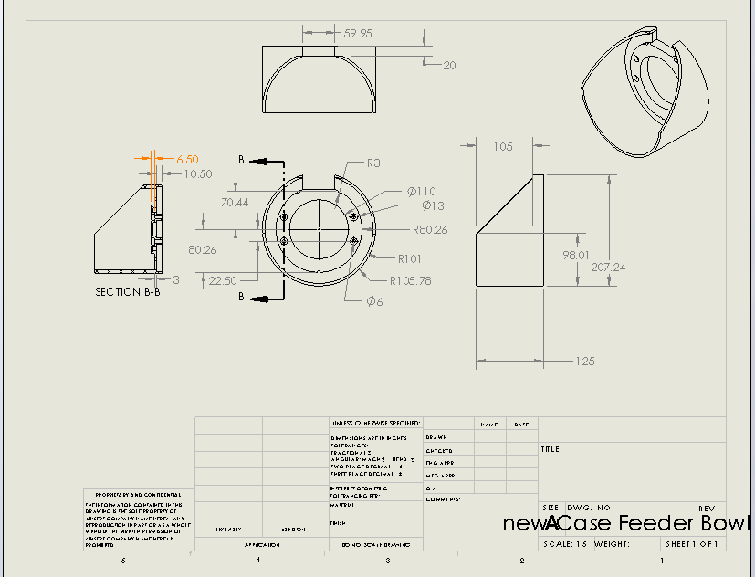Bowl

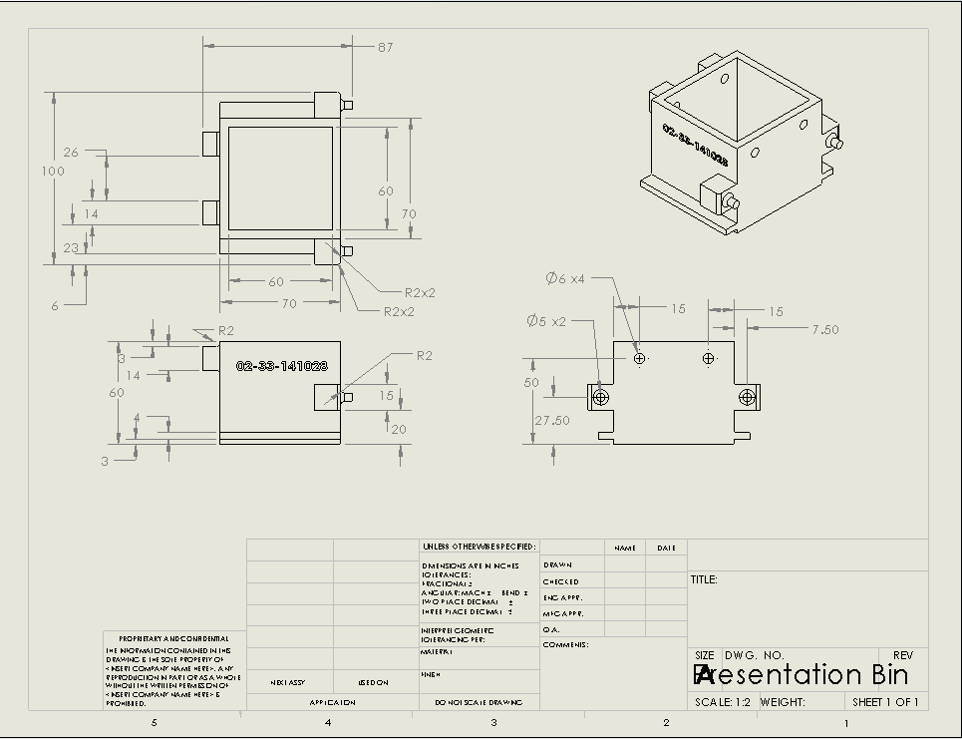Presentation Bin

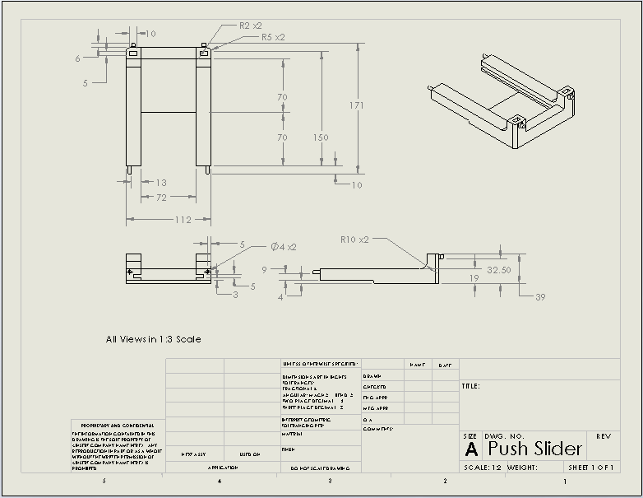Slider

Slider End

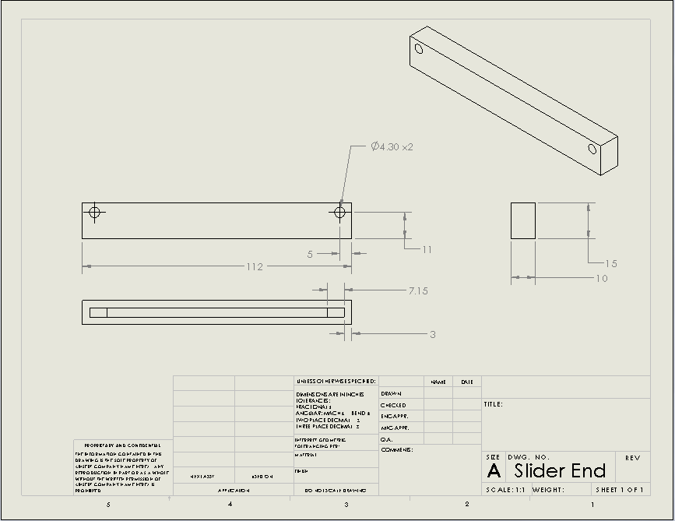

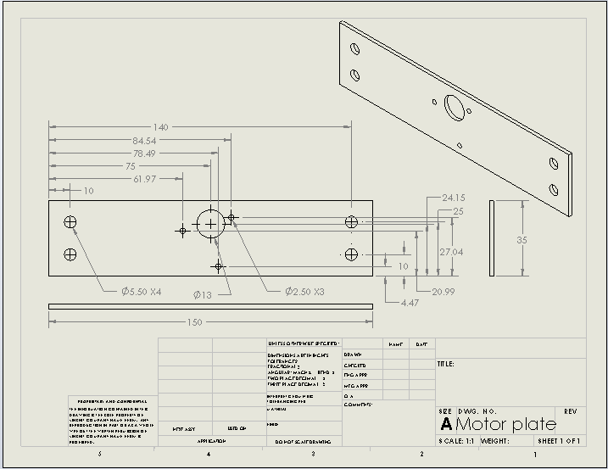Motor Plate

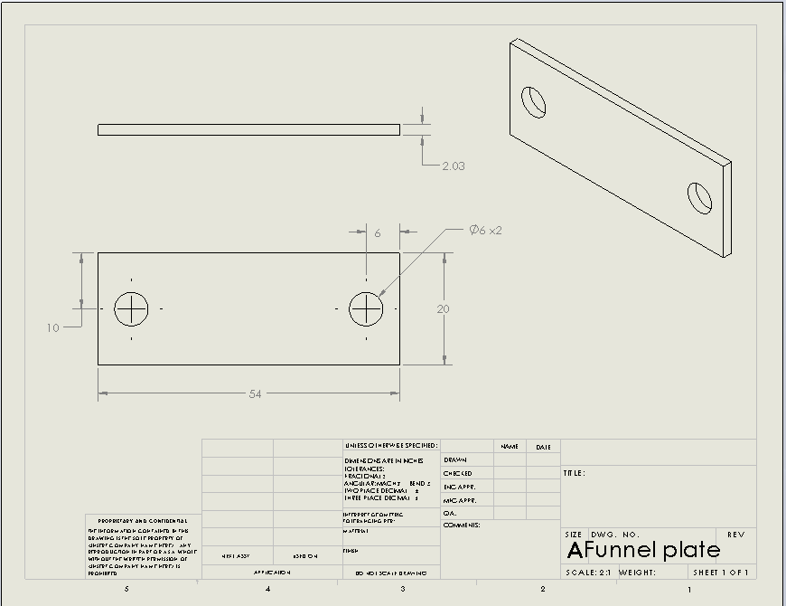Funnel Mounting Plate

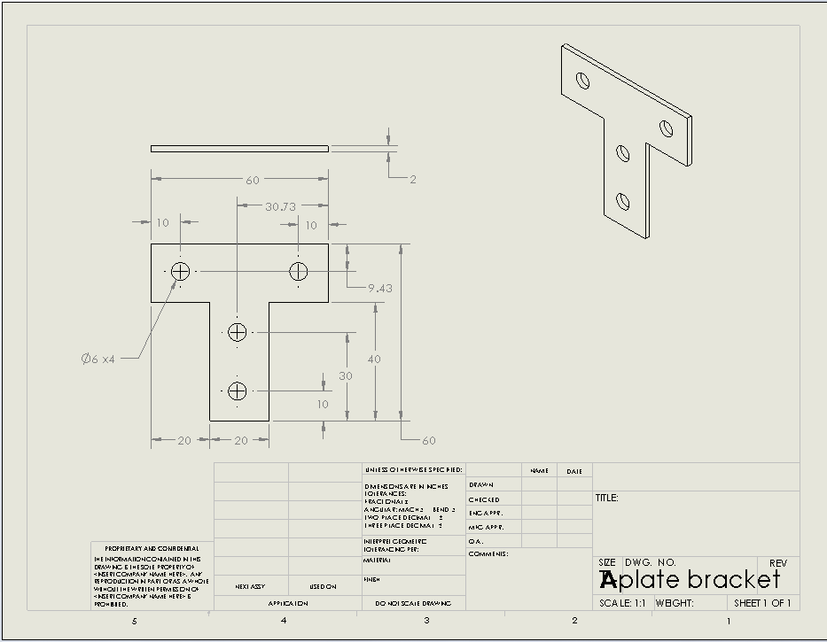T- Bracket Joint Plate

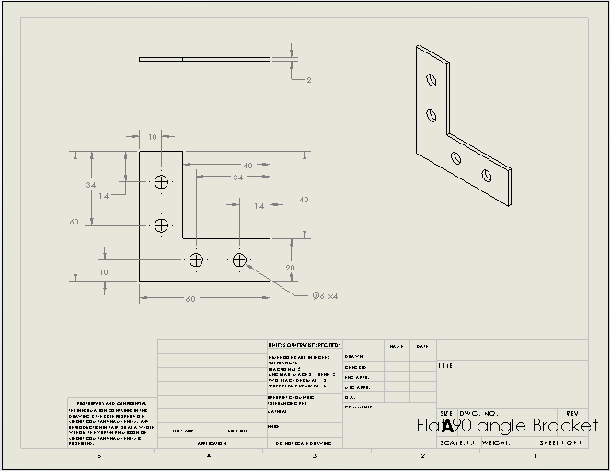L-Bracket Joint Plat

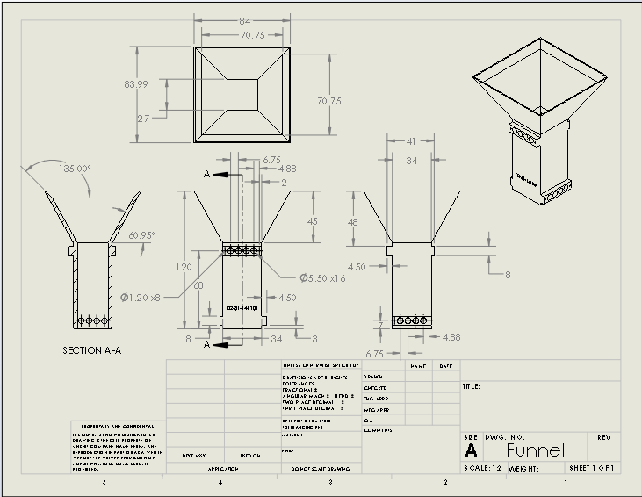Funnel

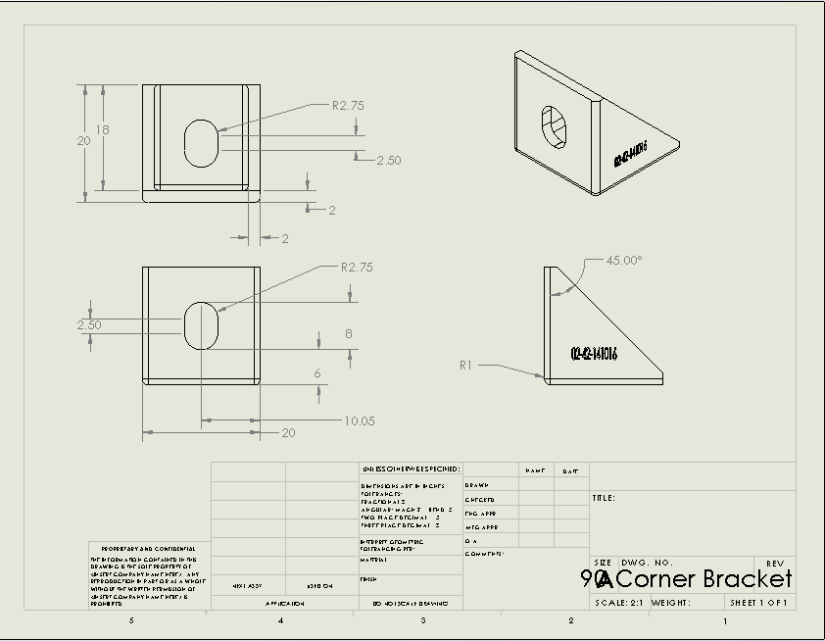90 Degree Angle Bracket

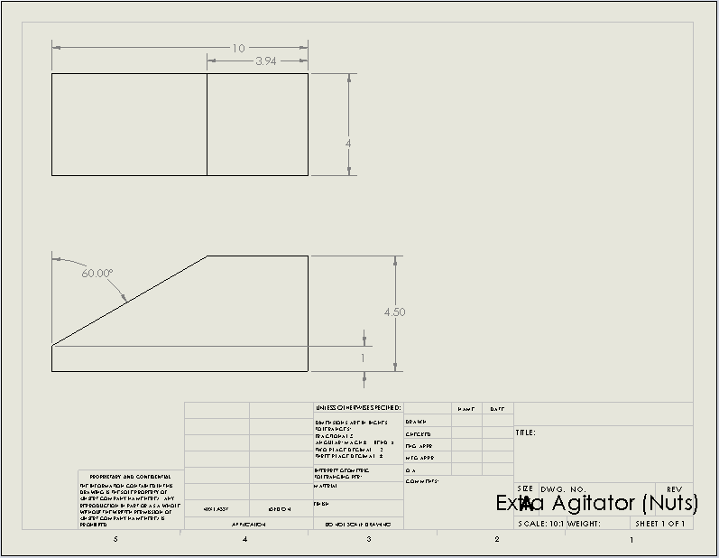Extra Plate Agitator

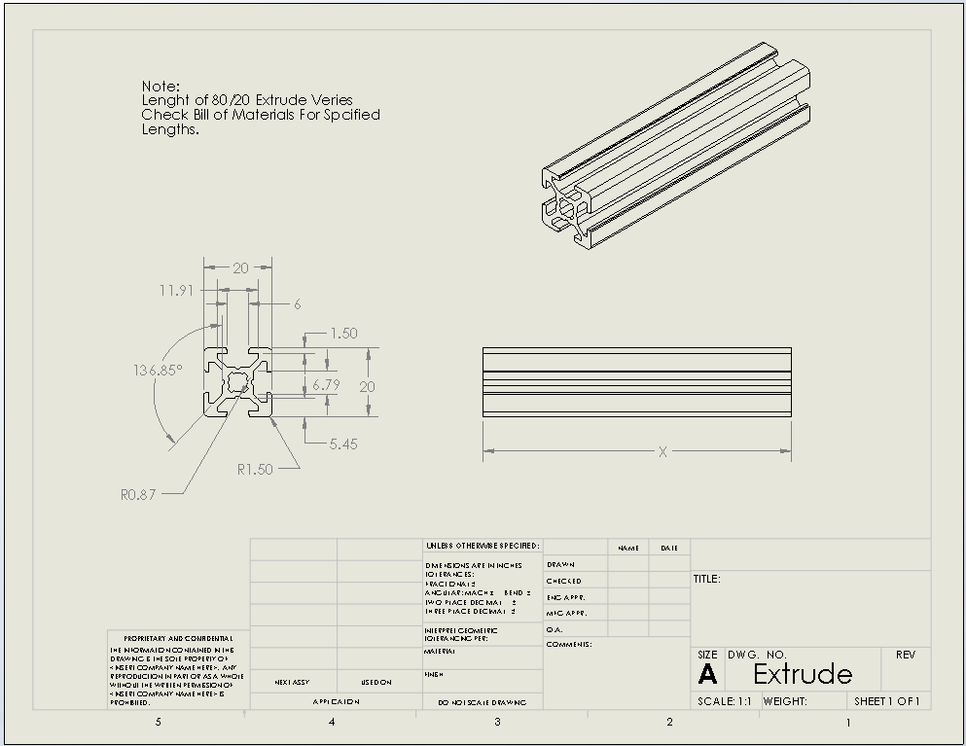80/20 Extrude

Appendix B: Test Data

Competition Fasteners Raw Stats

90 Bracket Test Raw Data

**Time Results for Part dispensing**

|  |  |  |  |
| --- | --- | --- | --- |
| **Part Type** | **# of Parts** | **Iteration** | **Time (s)** |
| 4 mm nut | 10 | 1 | 7.74 |
| 11 | 2 | 8.97 |
| 12 | 3 | 13.97 |
| 10 mm nut | 6 | 1 | 4.87 |
| 6 | 2 | 5.68 |
| 6 | 3 | 3.95 |
| 10x25 mm screw | 6 | 1 | 6.89 |
| 6 | 2 | 5.71 |
| 6 | 3 | 9.31 |
| 4x50mm screw | 6 | 1 | 16.68 |
| 6 | 2 | 11.02 |
| 6 | 3 | 6.85 |
| Drywall screw | 6 | 1 | 11.20 |
| 6 | 2 | 10.54 |
| 6 | 3 | 9.53 |
| Drywall anchor | 6 | 1 | 5.54 |
| 6 | 2 | 6.80 |
| 6 | 3 | 5.23 |

**Appendix C: Code**

**MATLAB Motor Simulation for Motor Control Needs Analysis**

%Control needs analysis of 12V Pittman 8224 motor with G35A wide-faced gear box

%% Set-up and motor variables

clc

clear all

Ke = 0.01;%[V/rad/s]

Kt = Ke;%Due to SI units

Km = Kt;%Therefore we have only one constant, a motor constant Km

Bm = 1.34e-6;% Viscous damping factor,[Nm*s/rad]

Jm = 1.62e-6;%Inertia of rotor, [kg*m^2]

La = 0.58e-3;%Armature Inductance, [H]

Ra = 1.17;%Armature Resistance, [Ohm]

n = 60.5;% Ratio of G35A gear box => wm/wl

Eff = 0.66;% Efficeincy of gear-box, losses due to gear box gear friction

neff = n*Eff;%Effective gear ratio of gear-box due to friction losses

Inl = 0.37;%No load current draw[A]

Tloss = Inl*Kt;% Torque loss due to the motor shaft [Nm]

%% Moments of Intertia and Damping due to load (average of all parts)

J_load = 0.0059;%[kg*m^2]

B_load = 0.0166;%[N*m*s/rad]

%% Mathematical modeling of motor transfer function

% Load is reffered to motor via effective gear ratio

% Model obtained from <A Journey from Robot to Digital Human>, pg. 298

% By: Edward Y.L. Gu, Springer, 2013

Jeff = Jm + (J_load/(neff)^2);%Effective inertia experienced by motor

Beff = Bm + (B_load/(neff)^2);%Effective damping experienced by motor

num = [(-La*Tloss) (Ra+Km)];

den = [(Jeff*La) ((Jeff*Ra) + (Beff*La) - (Km*Tloss)) ((Beff*Ra) + (Km^2) - (Ra*Tloss*Km))];

Sys = tf(num, den)%System TF

% Transfer function:

% -2.146e-006 s + 1.18

% ------------------------------------------

% 3.086e-009 s^2 - 3.077e-005 s + 7.046e-005

w_n = sqrt(((Beff*Ra) + (Km^2) - (Ra*Km*Tloss))/(Jeff*La))

% resonant frequnecy

% w_n =

%

% 151.1057

z = (0.5*((Jeff*Ra)+ (Beff*La) - (Km*Tloss))/sqrt(((Beff*Ra)+(Km^2)-(Ra*Km*Tloss))/(Jeff*La)))

%damping factor

% z =

%

% -1.0181e-007

%Graph of system step response

figure(1);

step(Sys)

**MATLAB Code for PID controller Design**

clear all;

clc;

Gear = 65.5;

Ka = (((1.63/1000)*60)/(2*pi))*Gear;

La = 1.16*10^-3;

Ra = 1.93;

Jm = (2.6*10^-5);

Jpl = 13.95*10^-3;

Je = Jm*Gear + Jpl;

Bm = 1.2*10^-5;

Bpl = .01;

Be = Bm*Gear + Bpl;

Eff = .66;

Tfriction = 0.14136;

A = [-(Ra/La) -(Ka/La); (Ka*Eff/Je) -(Be/Je)];

B = [1/La 0;0 -1/Je];

C = [1 0;0 1];

D = [0 0;0 0];

MotorSS = ss(A,B,C,D);

% figure(1);

% [u,t] = gensig('square',1/500,.15,.00001);

% U=[u*12 Tfriction*ones(length(u),1)];

% lsim(MotorSS,U,t);

% figure(2);

% U=[ones(length(u),1)*6 Tfriction*ones(length(u),1)];

% lsim(MotorSS,U,t);

%%

Kp = 100;

Ki = 2.5;

Kd = 0.095;

PWM = 12;

B = [1/La;0];

C = [0 1];

D = [0];

MotorSS = ss(A,B,C,D);

% C=pidtune(PWM*MotorSS,'pi');

C=pid(Kp,Ki,Kd);

System=feedback(C*(PWM*MotorSS),1);

figure(1);

step(System)

figure(2);

input = [ones(1000,1)*1;ones(1000,1)*2;ones(1000,1)*3;ones(1000,1)*4];

Inputs = [input];

lsim(System,Inputs,(0:(length(input)-1))*0.001)

**System Firmware**

|  |
| --- |
| Code: |
| #include <PID_v1.h>  //ButtonConstants  #define debounceDelay 90  #define selectC 0x02  #define upC 0x10  #define downC 0x04  #define backC 0x01  #define pauseC 0x08  #define dispensePin 40  #define redPin 38  #define greenPin 39  // Define ADC prescaler  const unsigned char PS_16 = (1 << ADPS2);  const unsigned char PS_128 = (1 << ADPS2) | (1 << ADPS1) | (1 << ADPS0);  //MotorConstants  #define motorPin 46  #define motorInA 50  #define motorInB 53  #define Kp .8  #define Ki .01  #define Kd .005  #define minPWM 32  #define sTime 20  #define numOfSamples 500  #define fourMMNutSetPoint 950  #define tenMMNutSetPoint 934  #define fiftyMMScrewSetPoint 952  #define twentyFiveMMScrewSetPoint 943  #define wallAnchorSetPoint 950  #define dryWallScrewSetPoint 952  #define shakeDelay 700  #define lightJam 830  #define heavyJam 640  #define blink_time 750  //Custom datatypes for LCD, motor, leds, and sensor states  typedef enum STATE_LCD  {  WELCOME,  SELECT_PART,  SELECT_AMOUNT,  CONFIRM,  LOADING,  COUNTING,  COMPLETE,  PAUSE,  ERROR_SENSOR,  ERROR_MOTOR,  ERROR_USER  } state_lcd;    typedef enum STATE_MOTOR  {  ON,  OFF,  } state_motor;    typedef enum STATE_SENSOR  {  ACTIVE,  STANDBY  } state_sensor;    typedef enum STATE_LED  {  ENABLED,  DISABLED,  BLINK,  } state_led;  //Structures for all controllers  typedef struct LCD_Controller  {  short amount;  short part;  boolean confirmation;  state_lcd state;  } LCD_Controller;    typedef struct Buttons  {  byte select;  long selectDB;  boolean selectF;  byte up;  long upDB;  boolean upF;  byte down;  long downDB;  boolean downF;  byte back;  long backDB;  boolean backF;  byte pause;  long pauseDB;  boolean pauseF;  byte dispense;  long dispenseDB;  boolean dispenseF;  } Buttons;    typedef struct Motor_Controller  {  state_motor state;  double peak;  double pwm;  double current;  double set_point;  int sample_num;  } Motor_Controller;    typedef struct SENSOR_CONTROLLER  {  boolean topHi;  boolean btmHi;  short top;  short btm;  short tempCount;  short partCount;  state_sensor state;  } sensor_controller;    typedef struct INDICATOR_CONTROLLER  {  boolean red;  long red_time;  state_led red_state;  boolean green;  long green_time;  state_led green_state;  } indicator_controller;  //Initialization of controllers  LCD_Controller LCD = {1,1,false,WELCOME};  Buttons BTNS = {0,0,false,0,0,false,0,0,false,0,0,false,0,0,false,0,0,false};  Motor_Controller motor = {OFF,0,0,0,SPT,0};  sensor_controller sensors = {false,false,0,0,0,0,STANDBY};  indicator_controller leds = {false,0,ENABLED,true,0,DISABLED};  PID PIDcontroller = PID(&motor.peak,&motor.pwm,&motor.set_point,Kp,Ki,Kd,DIRECT);  String part_name[] = {"50mm Cap Screw","4mm Hex Nut","25mm Cap Screw","10mm Hex Nut","Wall Anchor","Dry-wall Screw"};  state_lcd previous_state;  int jamReading = lightJam;  void setup()  {  Serial.begin(9600);  setup_adc();  setup_BTNS();  setup_motor();  setup_sensors();  lcd_setup();  update_LCD();  }  void loop()  {  process_input();  get_count();  control_motor();  control_leds();  }  //Displays correct text on LCD according to the state of the LCD  void update_LCD()  {  switch(LCD.state)  {  case WELCOME:  clear_lcd();  writeLCD(0x84);  writeLCD("Welcome!");  nextLine();  for(int i = 0;i<16; i++)  {  writeLCD("*");  delay(100);  }  LCD_next_screen();  update_LCD();  break;  case SELECT_PART:  clear_lcd();  writeLCD("Select Part:");  nextLine();  printLCD(part_name[LCD.part]);  break;  case SELECT_AMOUNT:  clear_lcd();  writeLCD("Select Amount:");  nextLine();  printLCD(String(LCD.amount));  break;  case CONFIRM:  clear_lcd();  writeLCD("Ready to begin?");  nextLine();  if(LCD.confirmation == false)  {  writeLCD("X No Yes");  }  else  {  writeLCD(" No X Yes");  }  break;  case COUNTING:  clear_lcd();  writeLCD("Counting...");  nextLine();  printLCD("Parts: " + String(sensors.partCount));  break;  case COMPLETE:  clear_lcd();  writeLCD(" * Ready to *");  nextLine();  writeLCD(" * Dispense! *");  break;  case PAUSE:  clear_lcd();  writeLCD("Count paused.");  nextLine();  printLCD("Parts: " + String(sensors.partCount));  break;  case ERROR_SENSOR:  clear_lcd();  setLCDCursor(5,1);  writeLCD("ERROR!");  nextLine();  writeLCD("Sensor failure.");  break;  case ERROR_MOTOR:  clear_lcd();  setLCDCursor(5,1);  writeLCD("ERROR!");  nextLine();  writeLCD("Motor failure.");  break;  case ERROR_USER:  clear_lcd();  setLCDCursor(5,1);  writeLCD("ERROR!");  nextLine();  writeLCD("Dispenser open.");  break;  }  }  //Transitions the LCD and controllers to the next state  void LCD_next_screen()  {  switch(LCD.state)  {  case WELCOME:  LCD.state = SELECT_PART;  break;  case SELECT_PART:  LCD.state = SELECT_AMOUNT;  break;  case SELECT_AMOUNT:  LCD.state = CONFIRM;  break;  case CONFIRM:  sensors.state = ACTIVE;  LCD.state = COUNTING;  break;  case COUNTING:  sensors.state = STANDBY;  LCD.state = COMPLETE;  break;  case PAUSE:  sensors.state = ACTIVE;  LCD.state = COUNTING;  break;  case COMPLETE:  sensors.state = ACTIVE;  LCD.state = COUNTING;  break;  case ERROR_SENSOR:  sensors.state = STANDBY;  LCD.state = SELECT_PART;  break;  case ERROR_MOTOR:  sensors.state = STANDBY;  LCD.state = SELECT_PART;  break;  case ERROR_USER:  sensors.state = STANDBY;  LCD.state = SELECT_PART;  break;  }  }    //Transitions LCD to previous state  void LCD_previous_screen()  {  switch(LCD.state)  {  case WELCOME:  break;  case SELECT_PART:  break;  case SELECT_AMOUNT:  LCD.state = SELECT_PART;  break;  case CONFIRM:  LCD.state = SELECT_AMOUNT;  break;  case COUNTING:  break;  case COMPLETE:  break;  case ERROR_SENSOR:  break;  case ERROR_MOTOR:  break;  case ERROR_USER:  break;  }  }  void process_input()  {  //registers input for all buttons on register A  byte buttonState = PINA;  switch(LCD.state)  {  case SELECT_PART:  if(upBTN(buttonState))  {  if(LCD.part != 5)  {  LCD.part++;  }  else  {  LCD.part = 0;  }  changeSetPoint();  update_LCD();  }  if(downBTN(buttonState))  {  if(LCD.part != 0)  {  LCD.part--;  }  else  {  LCD.part = 5;  }  changeSetPoint();  update_LCD();  }  if(selectBTN(buttonState))  {  LCD_next_screen();  update_LCD();  }  break;  case SELECT_AMOUNT:  if(upBTN(buttonState))  {  if(LCD.amount != 6)  {  LCD.amount++;  }  else  {  LCD.amount = 1;  }  update_LCD();  }  if(downBTN(buttonState))  {  if(LCD.amount != 1)  {  LCD.amount--;  }  else  {  LCD.amount = 6;  }  update_LCD();  }  if(selectBTN(buttonState))  {  LCD_next_screen();  update_LCD();  }  if(backBTN(buttonState))  {  LCD_previous_screen();  update_LCD();  }  break;  case CONFIRM:  if(upBTN(buttonState))  {  LCD.confirmation = !LCD.confirmation;  update_LCD();  }  if(downBTN(buttonState))  {  LCD.confirmation = !LCD.confirmation;  update_LCD();  }  if(selectBTN(buttonState))  {  if(LCD.confirmation)  {  leds.red_state = DISABLED;  leds.green_state = BLINK;  LCD_next_screen();  update_LCD();  motor.state = ON;  switch_motor();  }  }  if(backBTN(buttonState))  {  LCD_previous_screen();  update_LCD();  }  break;  case COUNTING:  if(pauseBTN(buttonState))  {  leds.red_state = ENABLED;  leds.green_state = DISABLED;  leds.green = true;  motor.state = OFF;  switch_motor();  LCD.state = PAUSE;  update_LCD();  }  break;  case PAUSE:  if(pauseBTN(buttonState))  {  leds.red_state = DISABLED;  leds.green_state = BLINK;  motor.state = ON;  switch_motor();  LCD.state = COUNTING;  update_LCD();  }  case COMPLETE:  if(dispenseBTN(digitalRead(dispensePin)))  {  delay(2000);  leds.red_state = DISABLED;  leds.green_state = BLINK;  sensors.partCount = 0;  sensors.state = ACTIVE;  motor.state = ON;  switch_motor();  LCD_next_screen();  update_LCD();  }  break;  case ERROR_SENSOR:  break;  case ERROR_MOTOR:  break;  case ERROR_USER:  break;  }  }    void control_leds()  {  if(leds.red_state == ON && leds.red == false)  {  digitalWrite(redPin,HIGH);  leds.red = true;  }  if(leds.red_state == OFF && leds.red == true)  {  digitalWrite(redPin,LOW);  leds.red = false;  }  if(leds.green_state == ON && leds.green == false)  {  digitalWrite(greenPin,HIGH);  leds.green = true;  }  if(leds.green_state == OFF && leds.green == true)  {  digitalWrite(greenPin,LOW);  leds.green = false;  }  if(leds.green_state == BLINK)  {  if(millis()-leds.green_time > blink_time)  {  digitalWrite(greenPin,leds.green);  leds.green = !leds.green;  leds.green_time = millis();  }  }  if(leds.red_state == BLINK)  {  if(millis() - leds.red_time > blink_time)  {  digitalWrite(redPin,!leds.red);  leds.red = !leds.red;  leds.red_time = millis();  }  }  }  //Sets register A as input and sets up LED Pins as outputs  void setup_BTNS()  {  DDRA = 0x00;  pinMode(dispensePin,INPUT);  pinMode(greenPin,OUTPUT);  pinMode(redPin,OUTPUT);  }  //All button methods. Debounces and prevents double button presses.  boolean selectBTN(byte buttonVals)  {  byte btnstate = buttonVals&selectC;  if (btnstate != BTNS.select)  {  BTNS.selectDB = millis();  BTNS.select = btnstate;  BTNS.selectF = true;  }    if ((millis() - BTNS.selectDB) > debounceDelay)  {  if(BTNS.selectF && BTNS.select != 0x00)  {  BTNS.selectF = false;  return true;  }  else  {  return false;  }  }  else  {  return false;  }  }  boolean upBTN(byte buttonVals)  {  byte btnstate = buttonVals&upC;    if (btnstate != BTNS.up)  {  BTNS.upDB = millis();  BTNS.up = btnstate;  BTNS.upF = true;  }    if ((millis() - BTNS.upDB) > debounceDelay)  {  if(BTNS.upF && BTNS.up != 0x00)  {  BTNS.upF = false;  return true;  }  else  {  return false;  }  }  else  {  return false;  }  }  boolean downBTN(byte buttonVals)  {  byte btnstate = buttonVals&downC;    if (btnstate != BTNS.down)  {  BTNS.downDB = millis();  BTNS.down = btnstate;  BTNS.downF = true;  }    if ((millis() - BTNS.downDB) > debounceDelay)  {  if(BTNS.downF && BTNS.down != 0x00)  {  BTNS.downF = false;  return true;  }  else  {  return false;  }  }  else  {  return false;  }  }  boolean backBTN(byte buttonVals)  {  byte btnstate = buttonVals&backC;    if (btnstate != BTNS.back)  {  BTNS.backDB = millis();  BTNS.back = btnstate;  BTNS.backF = true;  }    if ((millis() - BTNS.backDB) > debounceDelay)  {  if(BTNS.backF && BTNS.back != 0x00)  {  BTNS.backF = false;  return true;  }  else  {  return false;  }  }  else  {  return false;  }  }  boolean pauseBTN(byte buttonVals)  {  byte btnstate = buttonVals&pauseC;    if (btnstate != BTNS.pause)  {  BTNS.pauseDB = millis();  BTNS.pause = btnstate;  BTNS.pauseF = true;  }    if ((millis() - BTNS.pauseDB) > debounceDelay)  {  if(BTNS.pauseF && BTNS.pause != 0x00)  {  BTNS.pauseF = false;  return true;  }  else  {  return false;  }  }  else  {  return false;  }  }    boolean dispenseBTN(boolean buttonVals)  {  boolean btnstate = !buttonVals;    if (btnstate != BTNS.dispense)  {  BTNS.dispenseDB = millis();  BTNS.dispense = btnstate;  BTNS.dispenseF = true;  }    if ((millis() - BTNS.dispenseDB) > debounceDelay)  {  if(BTNS.dispenseF && BTNS.dispense != 0x00)  {  BTNS.dispenseF = false;  return true;  }  else  {  return false;  }  }  else  {  return false;  }  }  //LCD Methods  void lcd_setup()  {  Serial1.begin(19200);  writeLCD(0x16);  writeLCD(0x11);  }  void clear_lcd()  {  writeLCD(0x0C);  }  void setLCDCursor(int x, int y)  {  writeLCD(128+20*y+x);  }  void nextLine()  {  writeLCD(0x0D);  }  void printLCD(String text)  {  Serial1.print(text);  }  void writeLCD(char text[])  {  Serial1.write(text);  }  void writeLCD(int text)  {  Serial1.write(text);  }  //Motor Control Methods  //Sets the PWM to a certain frequency  void setPwmFrequency(int pin, int divisor)  {  byte mode;  if(pin == 5 || pin == 6 || pin == 9 || pin == 10) {  switch(divisor) {  case 1: mode = 0x01; break;  case 8: mode = 0x02; break;  case 64: mode = 0x03; break;  case 256: mode = 0x04; break;  case 1024: mode = 0x05; break;  default: return;  }  if(pin == 5 || pin == 6) {  TCCR0B = TCCR0B & 0b11111000 | mode;  } else {  TCCR1B = TCCR1B & 0b11111000 | mode;  }  } else if(pin == 3 || pin == 11) {  switch(divisor) {  case 1: mode = 0x01; break;  case 8: mode = 0x02; break;  case 32: mode = 0x03; break;  case 64: mode = 0x04; break;  case 128: mode = 0x05; break;  case 256: mode = 0x06; break;  case 1024: mode = 0x7; break;  default: return;  }  TCCR2B = TCCR2B & 0b11111000 | mode;  }  }    //Increases sampling rate of ADC with little or not effect on accuracy  void setup_adc()  {  ADCSRA &= ~PS_128;  ADCSRA |= PS_16;  }  //Samples current for numOfSamples and uses peak as input for PID controller  void control_motor()  {  if(motor.state == ON)  {  int reading = analogRead(15);  if(reading > motor.peak)  {  motor.peak = reading;  }  motor.sample_num++;  if(motor.sample_num >= numOfSamples)  {  motor.sample_num = 0;  motor.peak = 1024-motor.peak;  if(motor.peak > jamReading)  {  PIDcontroller.Compute();  analogWrite(motorPin,motor.pwm);  }  else  {  fix_jam();  }  motor.peak = 0;  }  }  }    //Sets ADC to use 1.1V reference, Sets A,B,and PWM pins as output, Sets PWM frequency to max, Sets PID controller output constraints, sample time, and mode.  void setup_motor()  {  analogReference(INTERNAL1V1);  pinMode(motorPin,OUTPUT);  pinMode(motorInA,OUTPUT);  pinMode(motorInB,OUTPUT);  setPwmFrequency(motorPin,1);  PIDcontroller.SetMode(AUTOMATIC);  PIDcontroller.SetOutputLimits(minPWM,255);  PIDcontroller.SetSampleTime(sTime);  }  void resetMotorVals()  {  motor.peak = 0;  motor.pwm = 0;  motor.sample_num = 0;  }  //Turns on and off motor according to the motor state  void switch_motor()  {  if(motor.state == ON)  {  resetMotorVals();  PIDcontroller.SetMode(AUTOMATIC);  digitalWrite(motorInB,LOW);  digitalWrite(motorInA,HIGH);  }  else  {  PIDcontroller.SetMode(MANUAL);  digitalWrite(motorInB,HIGH);  digitalWrite(motorInA,HIGH);  }  }    //Sensor Module Methods  //Sets register C as input  void setup_sensors()  {  DDRC = 0x00;  }  //Gets values from register C and applies bitmasks for upper and lower sensors groups  void readSensors()  {  byte sensorsRead = PINC ;  sensors.top = sensorsRead & 0xF0;  sensors.btm = sensorsRead & 0x00; //0x0F  }  void get_count()  {  if(sensors.state == ACTIVE)  {  readSensors();    //Uses double level algorithm for the small nuts  if(false)//LCD.part == 1 | LCD.part == 3)  {  if (false)//sensors.top != 0x00 && !sensors.topHi)  {  sensors.topHi=true;  sensors.tempCount ++;  delay(10);  }  else  {  if(sensors.top == 0x00)  {  sensors.topHi=false;  }  }  if (sensors.btm != 0x00 && !sensors.btmHi)  {  sensors.btmHi=true;  sensors.tempCount ++;  delay(10);  }  else  {  if(sensors.btm == 0x00)  {  sensors.btmHi=false;  }  }    if (sensors.tempCount!=0 && sensors.tempCount%2==0)  {  sensors.partCount ++;  sensors.tempCount = 0;  if(sensors.partCount < LCD.amount)  {  update_LCD();  }  else  {  LCD_next_screen();  leds.green_state = ENABLED;  leds.red_state = DISABLED;  update_LCD();  motor.state = OFF;  switch_motor();  }  }  }    //Uses single detection algorithm for longer parts  else  {  if (sensors.btm != 0x00 | sensors.top !=0x00)  {  sensors.partCount ++;  if(sensors.partCount < LCD.amount)  {  update_LCD();  }  else  {  LCD_next_screen();  leds.green_state = ENABLED;  leds.red_state = DISABLED;  motor.state = OFF;  switch_motor();  update_LCD();  }  delay(350);  }  }  }  }  void fix_jam()  {  digitalWrite(motorInB,HIGH);  digitalWrite(motorInA,HIGH);  delay(50);  analogWrite(motorPin,150);  for(int k = 0; k<5; k++)  {  digitalWrite(motorInB,HIGH);  digitalWrite(motorInA,LOW);  for(int i=0;i<shakeDelay;i++)  {  get_count();  }  digitalWrite(motorInA,HIGH);  delay(50);  digitalWrite(motorInB,LOW);  for(int i=0;i<shakeDelay/2;i++)  {  get_count();  }  delay(50);  }  analogWrite(motorPin,0);  PIDcontroller.Compute();    digitalWrite(motorInB,LOW);  digitalWrite(motorInA,HIGH);  }  void changeSetPoint()  {  switch(LCD.part)  {  case 0:  motor.set_point = fiftyMMScrewSetPoint;  jamReading = lightJam;  break;  case 1:  motor.set_point = fourMMNutSetPoint;  jamReading = lightJam;  break;  case 2:  motor.set_point = twentyFiveMMScrewSetPoint;  jamReading = heavyJam;  break;  case 3:  motor.set_point = tenMMNutSetPoint;  jamReading = heavyJam;  break;  case 4:  motor.set_point = wallAnchorSetPoint;  jamReading = lightJam;  break;  case 5:  motor.set_point = dryWallScrewSetPoint;  jamReading = lightJam;  break;  }  } |

**Appendix D: Derivations**

**Motor model derivation**

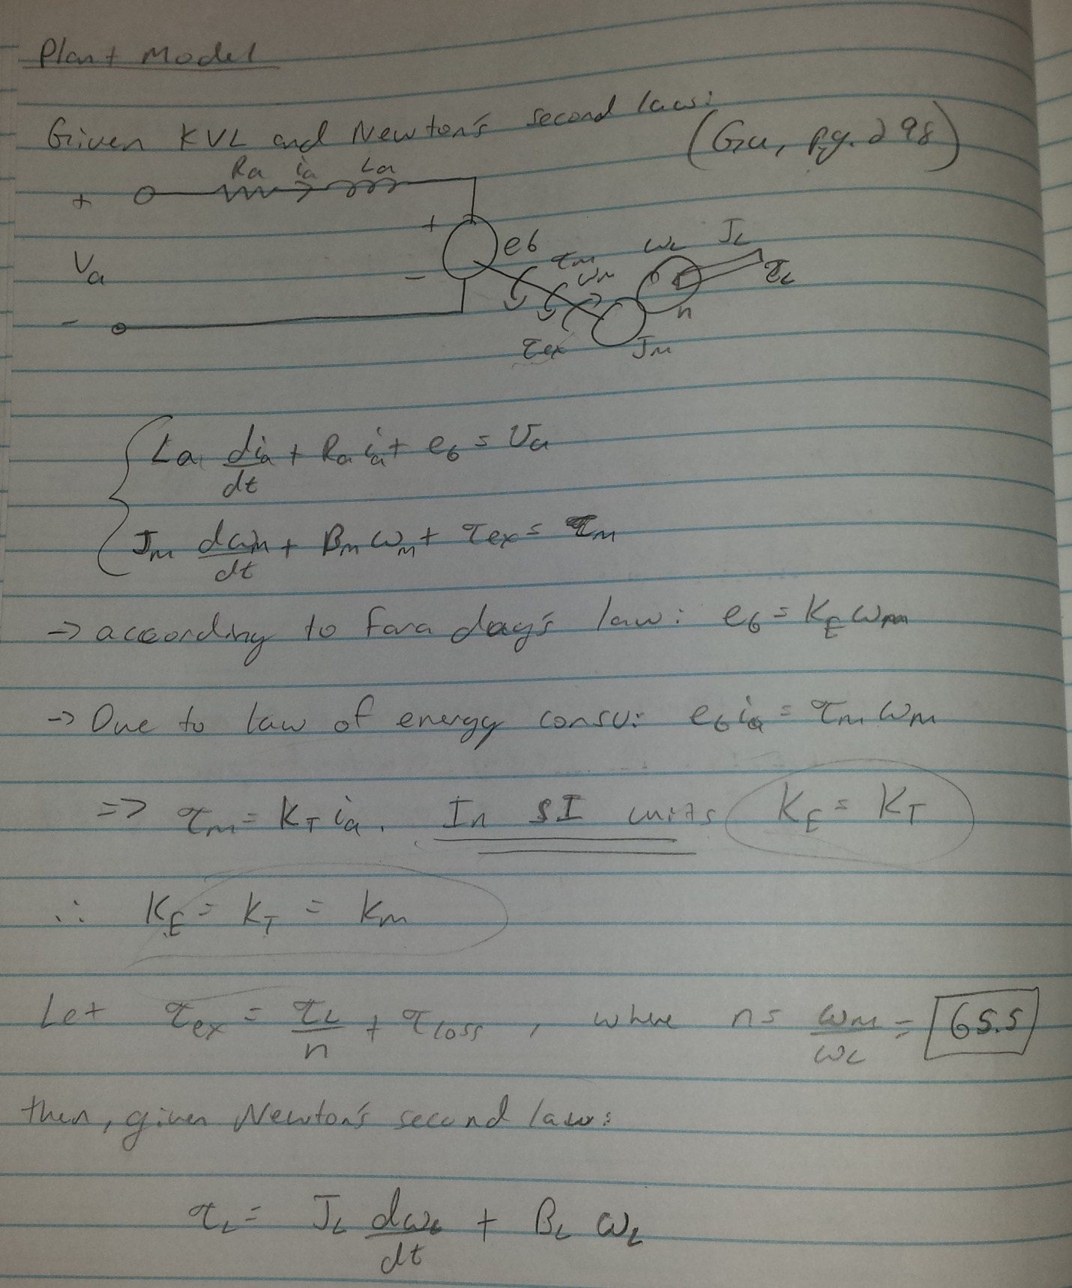

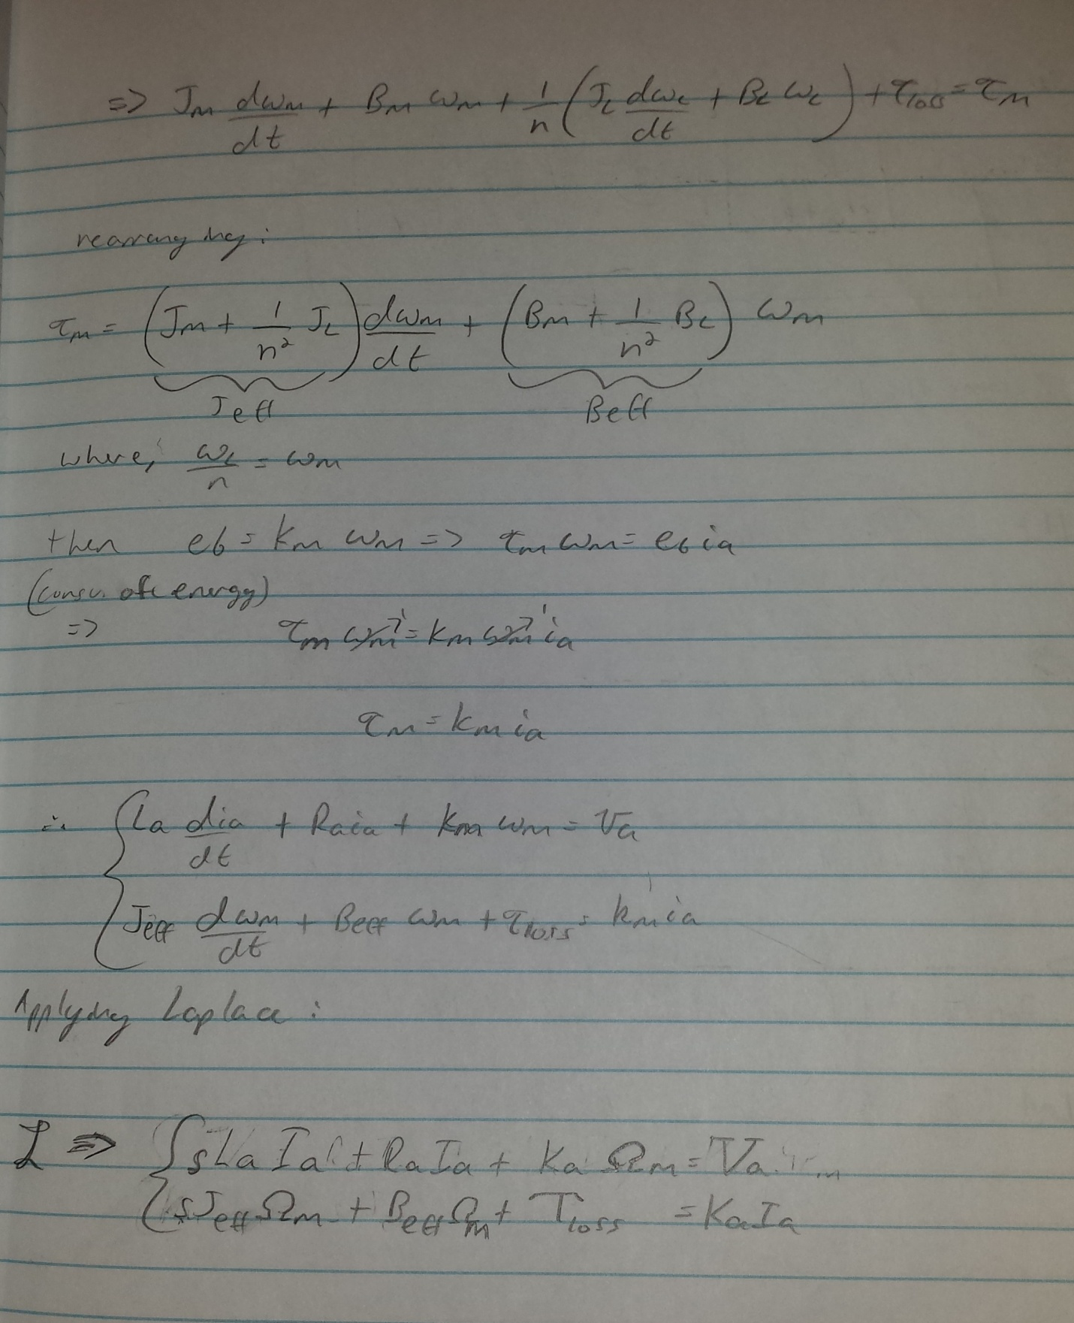

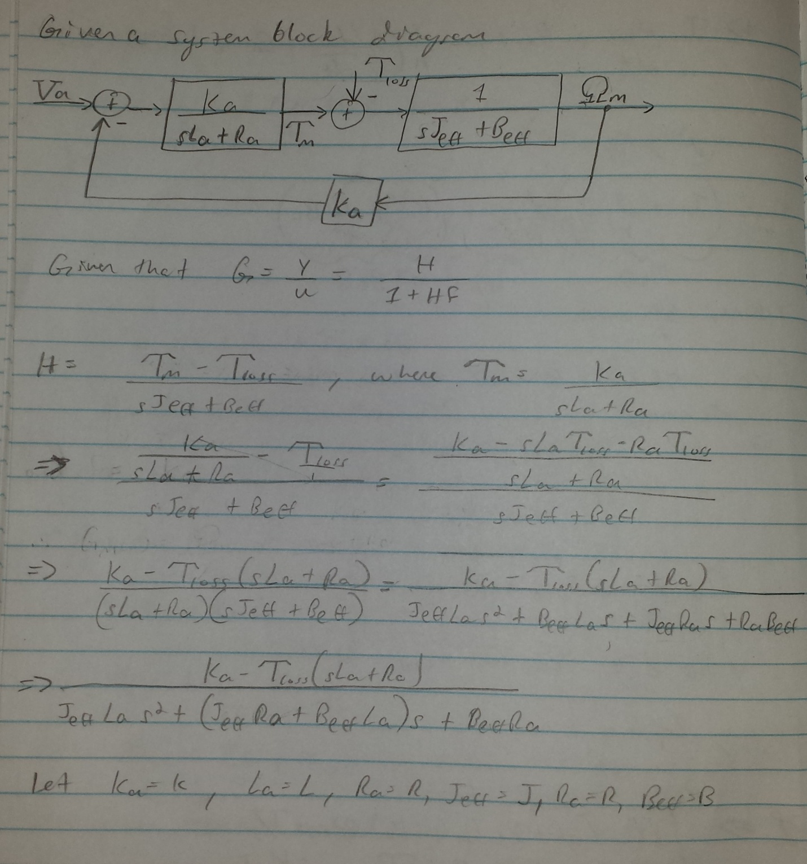

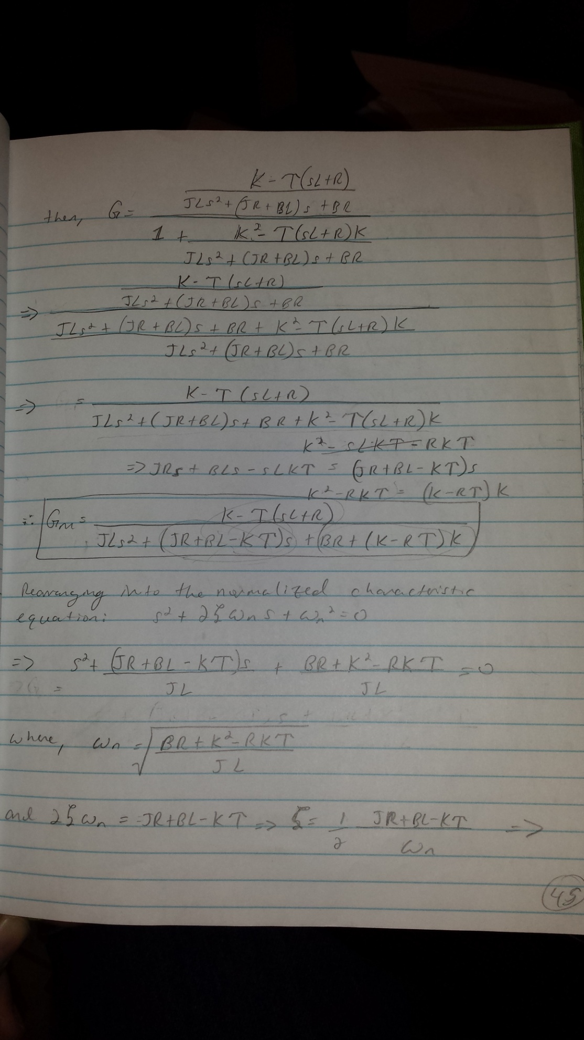

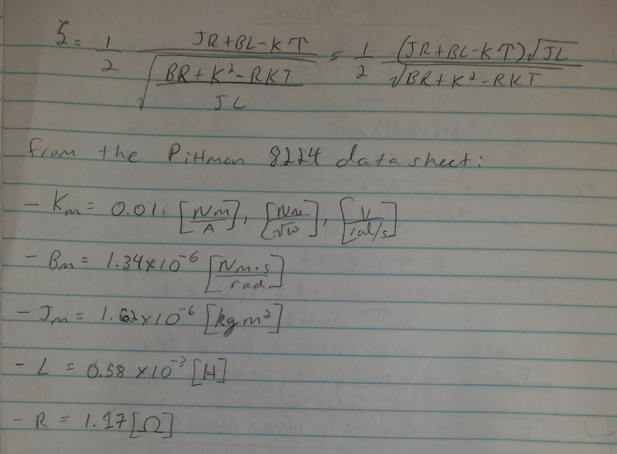

**Appendix E: System Requirements**

**Fall 2014 Senior Project**

**System Requirements**

**Group 2**

**V1.0**

September 7, 2014

**Revision History:**

|  |  |  |
| --- | --- | --- |
| **Version** | **Comments** | **Updated By:** |
| 1.0 | Initial release | P. Kruchko |
|  |  |  |
|  |  |  |
|  |  |  |
|  |  |  |
|  |  |  |
|  |  |  |
|  |  |  |
|  |  |  |
|  |  |  |
|  |  |  |
|  |  |  |
|  |  |  |
|  |  |  |
|  |  |  |
|  |  |  |
|  |  |  |

**Overview**: For the Fall 2014 semester, we will build, test, and compete with devices that will count small parts (screws, bolts, nuts and other fasteners) and deliver them upon request, with the goal to immediately deliver the exact number of parts when they are requested.[1]

**Objective of document:** To capture, define, and refine customer requirements to derive a set of specific system level requirements from which the more detailed aspects of the system can be identified to further and more accurately specify the electrical, mechanical, and computational needs of the system that must be met in order to implement a product that satisfies the customer requirements.

**Scope:** To provide the initial framework for Group 2 to further refine the requirements of the system so that an accurate system architecture and model can be subsequently created.

[1] Taken from Senior Design Syllabus, per Dr. Michael Latcha.

**Glossary of terms:**

Architectural Requirements: Describes what has to be done by identifying the necessary system architecture.

Functional Requirements: Describes the functionality that the system is to execute.

Non-Functional Requirements: Describes characteristics of the system that the user cannot affect or immediately perceive.

Constraint Requirements: Identifies the limits imposed upon the design that system must operate within.

|  |  |  |  |
| --- | --- | --- | --- |
| Acronym | Term | Example |  |
| FR-X | Functional Requirement, numbered X | FR-1 |  |
| AR-X | Architectual Requirement, numbered X | AR-1 |  |
| CR-X | Constraint Requirement, numbered X | CR-1 |  |
| NFR-X | Non-Functional Requirement, numbered X | NFR-1 |  |
| TBR | To Be Refined-Need to know more specific info | Qty.(4) 6 mm hex nuts |  |
|  |  |  |  |
|  |  |  |  |

**Table of Requirements:**

|  |  |  |  |
| --- | --- | --- | --- |
| **Requirements Tag** | **Description** | **Requirement** | **TBR** |
| FR-1 | Types of parts to be dispensed | The system shall dispense a variety of 5-6 different types of small mechanical fasteners such as screws, bolts, nuts, washers and plastic trim pieces | What kind of parts? Need to know the exact types of parts that are going to be included in the spectrum of parts to be dispensed. i.e. hex nuts, wing nuts, flat washers, spring washers, etc. |
| AR-1 | Size and form factor of system | The system shall be small, adaptable, and configurable | How small? What are the minimum and maximum dimensions that the system should be? Adaptable to what type of conditions? How configurable? Manually configurable or automatically configurable? What does it have to be configured for? What does it have to be configured to do? |
| FR-2 | Amount of parts to be dispensed | The system shall dispense between 1-6 of the small parts on a given dispense cycle |  |
| FR-3 | Adjustment for quantity | The system shall be easily adjusted to dispense the desired amount of parts | How adjusted? What is the user interface for part quantity adjustment? |
| FR-4 | Accommodation of size of parts | The system shall accommodate different sizes for the parts to be dispensed | What is the minimum size? What is the maximum size? What are the dimensions of the trim pieces to be dispensed? |
| CR-1 | Dispense Cycle Time | The system shall perform one parts dispense cycle within 30 seconds. With a dispense cycle being defined as beginning with the user interaction with the system and ending when the system dispenses the parts into the hands of the user |  |
| FR-5 | Delivery Mechanism | The system shall dispense the parts to the user's opened hand by mass transport through a chute system | To refine the dimensions and material of the chute system. Also angle of it's major line of axis and position with respect to the base of the system. |
| FR-6 | Method of part storage | The system shall store the parts to be dispensed in a container | What are the dimensions of the container? What material shall the container be constructed from? How is the container fastened to the system's machine frame? |
| CR-2 | Number of dispense cycles | The system shall perform at least 3 dispense cycles |  |
| FR-7 | Total quantity of parts that need to be dispensed from the system | The system shall be able to store enough parts to be able to meet the maximum possible amount of parts that can be dispensed for a given dispense cycle i.e. 3 dispense cycles and 6 parts maximum = 18 parts minimum that the system needs to be able to dispense |  |
| CR-3 | Accuracy of dispense cycle | The system shall be 100% accurate in quantity of parts dispensed per user input 100% of the time. |  |
| AR-2 | System power |  | What is to be the power source for the system? |
| CR-4 | System power constraints |  | What is the maximum voltage that the system should operate at? Minimum voltage? What is max constant current draw of the system? What is the max peak current draw for the system? |

**References:**

[1] CMU Microdynamic Systems Laboratory <http://www.msl.ri.cmu.edu/projects/minifactory/partsfeeders.php>

[2] “*Toothpick packing machine”*, GRT Machine & Tool Co., Ltd <https://www.youtube.com/watch?v=JfCTuXfHzrY> Oct 2, 2011

[3] “*Rotary Feeders”*, Catalyst Connection, <https://www.youtube.com/watch?v=9pWtjwkrPCs>, Feb 16 2010

[4] “*Homemade Case feeder”,* <http://www.youtube.com/watch?v=JH-7d9IuVqY>July 18, 2009

[5] “*Dillin Accumulation and Recirclation Table”*, Dillin Automation <http://www.youtube.com/watch?v=QgxFMs6k-Hs> , Aug 21, 2013

[6] “*10 0165 Bi Flo Accumulation Table green containers”,* General Conveyor, [tp://www.youtube.com/watch?v=edlPr0UNVYY](http://www.youtube.com/watch?v=edlPr0UNVYY) Jul 15, 2012

[7] “*Granola Bar Accumulation Table and Single Filer”,* garveycorp, <http://www.youtube.com/watch?v=BBqOjUgIN2g>, Dec 3, 2009

[8] “*SolidWorks Animator Tutorial”,*<http://www.youtube.com/watch?v=rd6DqjREv-w>, Jan 19, 2012

[9] “*3D Printing/FDM Guidelines”,* Latcha, M,<http://www.secs.oakland.edu/~latcha/me492/3Dprinting.html>

[10] “*Fall 2014 Design Project Descriptions”,* Latcha, M, <http://www.secs.oakland.edu/~latcha/me492/proj_f14.html>, Sept 4, 2014

[11] “*Technical Data of DIN”,*<http://almetal.nl/techinfo/nut/nd562.htm>

[12] “*Fastener CAD Data”,* [**http://www.mcmaster.com/#**](http://www.mcmaster.com/)

[13] “*Aluminum Extusions”,*[**http://www.grainger.com/category/aluminum-extrusions/structural-framing-systems/material-handling/ecatalog/N-c3qZ1z0qh5v**](http://www.grainger.com/category/aluminum-extrusions/structural-framing-systems/material-handling/ecatalog/N-c3qZ1z0qh5v)

[14] “*20 Series Slotted Framing”,*[**http://www.8020.net/**](http://www.8020.net/)

[15] *“Help”*[**http://www.solidworks.com/**](http://www.solidworks.com/)

[16] Kalpakjian,S, Schmid, S, “*Manufacturing Processes for Engineering Materials Fifth Edition*” Prentice Hall, Inc. 2008Pgs 15-18, 58-66, & 141

[17] “*Pressure Unit Conversion,”*<http://www.unit-conversion.info/pressure.html> 2014

[18] Gu, Edward Y.L. “A Journey from Robot to Digital Human” Springer-Verlag Berlin Heidelberg 2013

[19] Pittman/AMETEK “ Servo Motor Application Notes” <http://www.pittman-motors.com/>

[20] Alldatasheet.com “NCP11175T50T3G” <http://www.alldatasheet.com/view.jsp?Searchword=NCP11175T50T3G>

[21] Arduino (2014). Arduino Mega 2560. Retrieved from: http://arduino.cc/en/Main/arduinoBoardMega2560

[22] Fairchild Semiconductor (2013). LM78XX/LM78XXA 3-Terminal Voltage Regulator. Retrieved from: https://www.fairchildsemi.com/datasheets/LM/LM7805.pdf

[23] Beauregard, B. (2012). Arduino PID Library. Retrieved from: https://github.com/br3ttb/Arduino-PID-Library/